UNITED STATES
SECURITIES AND EXCHANGE COMMISSION
Washington, D.C. 20549

FORM 8-K

CURRENT REPORT
Pursuant to Section 13 or 15(d) of the Securities Exchange Act of 1934

Date of Report (Date of earliest event reported): July 28, 2026

BrightSpire Capital, Inc.
(Exact name of registrant as specified in its charter)

Maryland |  |  |  |  |  | 001-38377 |  |  |  |  |  | 38-4046290
(State or other jurisdiction |  |  |  |  |  | (Commission |  |  |  |  |  | (IRS Employer
of incorporation) |  |  |  |  |  | File Number) |  |  |  |  |  | Identification No.)

590 Madison Avenue, 33rd Floor
New York, NY 10022
(Address of Principal Executive Offices, Including Zip Code)

Registrant’s telephone number, including area code: (212) 547-2631

Not Applicable
(Former name or former address, if changed since last report)

Check the appropriate box below if the Form 8-K filing is intended to simultaneously satisfy the filing obligation of the registrant under any of the following provisions:

☐ Written communications pursuant to Rule 425 under the Securities Act (17 CFR 230.425)

☐ Soliciting material pursuant to Rule l4a-12 under the Exchange Act (17 CFR 240.14a-12)

☐ Pre-commencement communications pursuant to Rule 14d-2(b) under the Exchange Act (17 CFR 240.14d-2(b))

☐ Pre-commencement communications pursuant to Rule 13e-4(c) under the Exchange Act (17 CFR 240.13e-4(c))

Securities registered pursuant to Section 12(b) of the Act:
Title of each class |  |  |  |  |  | Trading Symbol(s) |  |  |  |  |  | Name of each exchange on which registered
Class A common stock, par value $0.01 per share |  |  |  |  |  | BRSP |  |  |  |  |  | New York Stock Exchange

Indicate by check mark whether the registrant is an emerging growth company as defined in Rule 405 of the Securities Act of 1933 (§230.405 of this chapter) or Rule 12b-2 of the Securities Exchange Act of 1934 (§240.12b-2 of this chapter).

Emerging growth company ☐
If an emerging growth company, indicate by check mark if the registrant has elected not to use the extended transition period for complying with any new or revised financial accounting standards provided pursuant to Section 13(a) of the Exchange Act. ☐

Item 2.02 |  |  | Results of Operations and Financial Condition.
On July 28, 2026, BrightSpire Capital, Inc. (the “Company”) issued a press release announcing its financial position as of June 30, 2026 and its financial results for the second quarter ended June 30, 2026. A copy of the press release is attached as Exhibit 99.1 to this Current Report on Form 8-K and is incorporated herein by reference.
On July 28, 2026, the Company made available a Supplemental Financial Disclosure Presentation for the second quarter ended June 30, 2026 on the Company’s website at www.brightspire.com. A copy of the Supplemental Financial Disclosure Presentation is furnished herewith as Exhibit 99.2 to this Current Report on Form 8-K and is incorporated herein by reference.
In accordance with General Instructions B.2 and B.6 of Form 8-K, the information included in Item 2.02 and Item 9.01 of this Current Report on Form 8-K (including Exhibits 99.1 and 99.2 hereto), shall not be deemed “filed” for the purposes of Section 18 of the Securities Exchange Act of 1934, as amended (the “Exchange Act”), or otherwise subject to the liabilities of that section, nor shall it be deemed incorporated by reference into any filing made by the Company under the Exchange Act or Securities Act of 1933, as amended, except as shall be expressly set forth by specific reference in such a filing.
Use of Website to Distribute Material Company Information
The Company’s website address is www.brightspire.com. The Company uses its website as a channel of distribution for important company information. Important information, including press releases, analyst presentations and financial information regarding the Company, is routinely posted on and accessible on the Shareholders subpage of its website, which is accessible by clicking on the tab labeled “Shareholders” on the website home page. The Company also uses its website to expedite public access to time-critical information regarding the Company in advance of or in lieu of distributing a press release or a filing with the U.S. Securities and Exchange Commission disclosing the same information. Therefore, investors should look to the Shareholders subpage of the Company’s website for important and time-critical information. Visitors to the Company’s website can also register to receive automatic e-mail and other notifications alerting them when new information is made available on the Shareholders subpage of the website.
Item 9.01 |  |  | Financial Statements and Exhibits.
(d) Exhibits. The following exhibits are being furnished herewith to this Current Report on Form 8-K.

Exhibit No. |  |  |  |  |  | Description
99.1 |  |  |  |  |  | Press Release, dated July 28, 2026
99.2 |  |  |  |  |  | Supplemental Financial Disclosure Presentation for the second quarter ended June 30, 2026
104 |  |  |  |  |  | Cover Page Interactive Data File (embedded within the Inline XBRL document)

SIGNATURE

Pursuant to the requirements of the Securities Exchange Act of 1934, the registrant has duly caused this report to be signed on its behalf by the undersigned hereunto duly authorized.

Date: July 28, 2026 |  |  | BRIGHTSPIRE CAPITAL, INC.
 |  |  | By: |  |  | /s/ David A. Palamé
 |  |  | Name: |  |  | David A. Palamé
 |  |  | Title: |  |  | General Counsel & Secretary

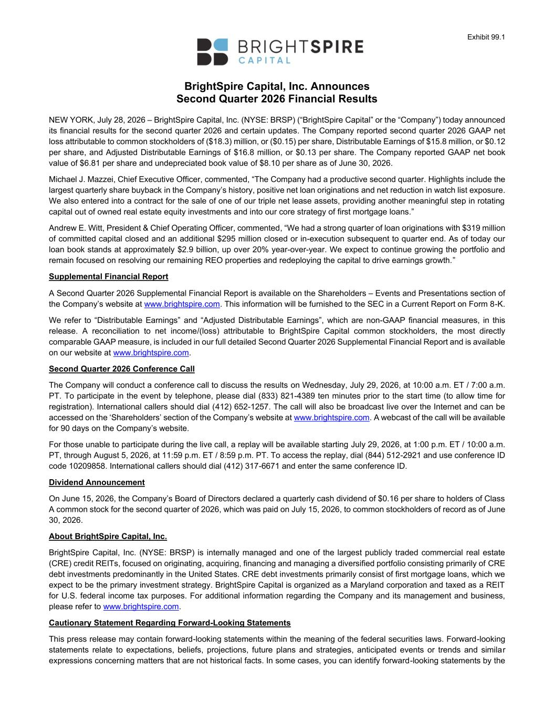

Exhibit 99.1 BrightSpire Capital, Inc. Announces Second Quarter 2026 Financial Results NEW YORK, July 28, 2026 – BrightSpire Capital, Inc. (NYSE: BRSP) (“BrightSpire Capital” or the “Company”) today announced its financial results for the second quarter 2026 and certain updates. The Company reported second quarter 2026 GAAP net loss attributable to common stockholders of ($18.3) million, or ($0.15) per share, Distributable Earnings of $15.8 million, or $0.12 per share, and Adjusted Distributable Earnings of $16.8 million, or $0.13 per share. The Company reported GAAP net book value of $6.81 per share and undepreciated book value of $8.10 per share as of June 30, 2026. Michael J. Mazzei, Chief Executive Officer, commented, “The Company had a productive second quarter. Highlights include the largest quarterly share buyback in the Company’s history, positive net loan originations and net reduction in watch list exposure. We also entered into a contract for the sale of one of our triple net lease assets, providing another meaningful step in rotating capital out of owned real estate equity investments and into our core strategy of first mortgage loans.” Andrew E. Witt, President & Chief Operating Officer, commented, “We had a strong quarter of loan originations with $319 million of committed capital closed and an additional $295 million closed or in-execution subsequent to quarter end. As of today our loan book stands at approximately $2.9 billion, up over 20% year-over-year. We expect to continue growing the portfolio and remain focused on resolving our remaining REO properties and redeploying the capital to drive earnings growth.” Supplemental Financial Report A Second Quarter 2026 Supplemental Financial Report is available on the Shareholders – Events and Presentations section of the Company’s website at www.brightspire.com. This information will be furnished to the SEC in a Current Report on Form 8-K. We refer to “Distributable Earnings” and “Adjusted Distributable Earnings”, which are non-GAAP financial measures, in this release. A reconciliation to net income/(loss) attributable to BrightSpire Capital common stockholders, the most directly comparable GAAP measure, is included in our full detailed Second Quarter 2026 Supplemental Financial Report and is available on our website at www.brightspire.com. Second Quarter 2026 Conference Call The Company will conduct a conference call to discuss the results on Wednesday, July 29, 2026, at 10:00 a.m. ET / 7:00 a.m. PT. To participate in the event by telephone, please dial (833) 821-4389 ten minutes prior to the start time (to allow time for registration). International callers should dial (412) 652-1257. The call will also be broadcast live over the Internet and can be accessed on the ‘Shareholders’ section of the Company’s website at www.brightspire.com. A webcast of the call will be available for 90 days on the Company’s website. For those unable to participate during the live call, a replay will be available starting July 29, 2026, at 1:00 p.m. ET / 10:00 a.m. PT, through August 5, 2026, at 11:59 p.m. ET / 8:59 p.m. PT. To access the replay, dial (844) 512-2921 and use conference ID code 10209858. International callers should dial (412) 317-6671 and enter the same conference ID. Dividend Announcement On June 15, 2026, the Company’s Board of Directors declared a quarterly cash dividend of $0.16 per share to holders of Class A common stock for the second quarter of 2026, which was paid on July 15, 2026, to common stockholders of record as of June 30, 2026. About BrightSpire Capital, Inc. BrightSpire Capital, Inc. (NYSE: BRSP) is internally managed and one of the largest publicly traded commercial real estate (CRE) credit REITs, focused on originating, acquiring, financing and managing a diversified portfolio consisting primarily of CRE debt investments predominantly in the United States. CRE debt investments primarily consist of first mortgage loans, which we expect to be the primary investment strategy. BrightSpire Capital is organized as a Maryland corporation and taxed as a REIT for U.S. federal income tax purposes. For additional information regarding the Company and its management and business, please refer to www.brightspire.com. Cautionary Statement Regarding Forward-Looking Statements This press release may contain forward-looking statements within the meaning of the federal securities laws. Forward-looking statements relate to expectations, beliefs, projections, future plans and strategies, anticipated events or trends and similar expressions concerning matters that are not historical facts. In some cases, you can identify forward-looking statements by the

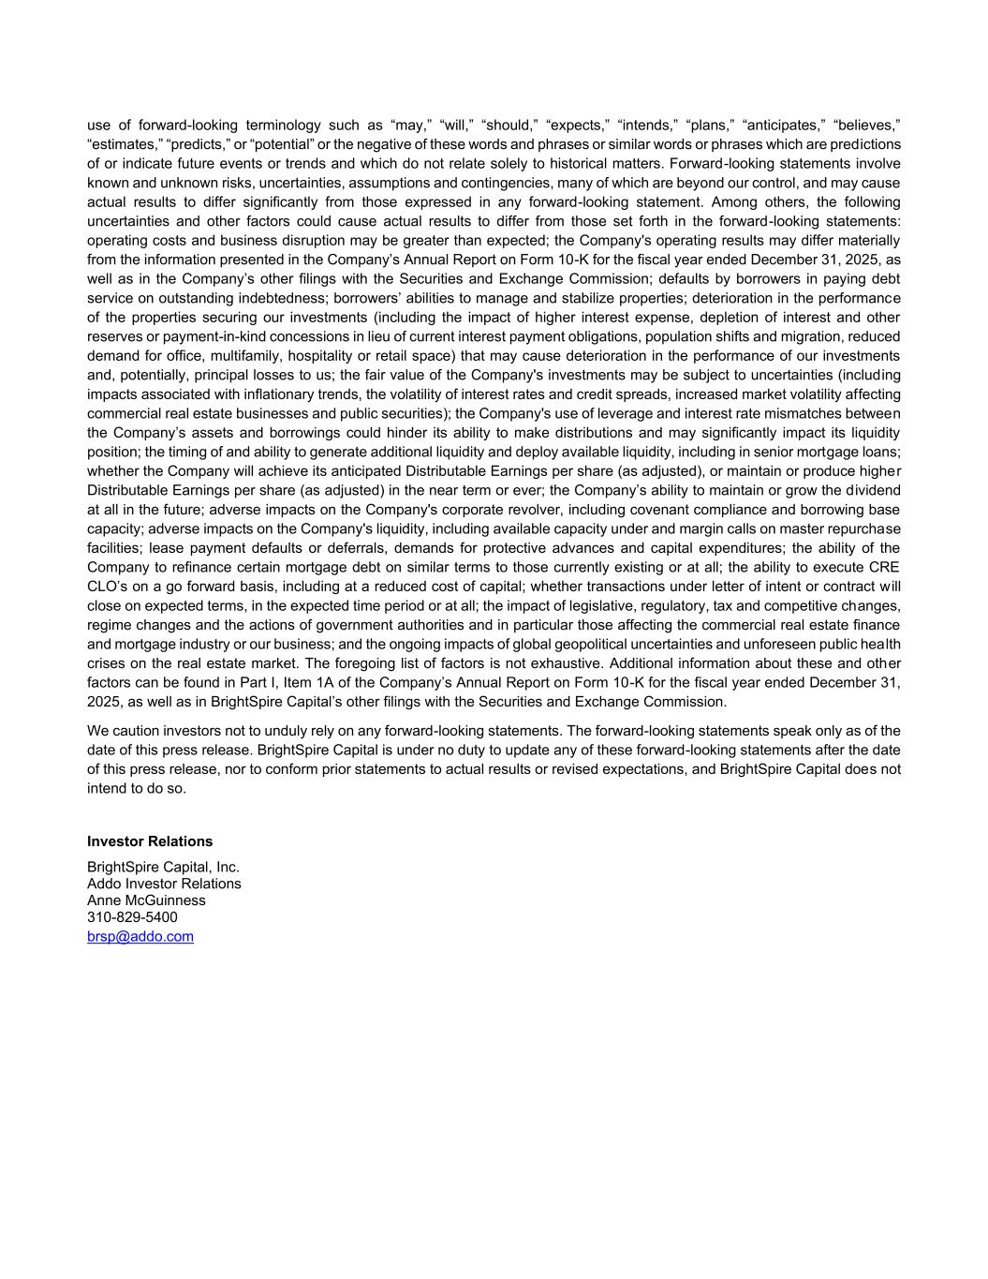
use of forward-looking terminology such as “may,” “will,” “should,” “expects,” “intends,” “plans,” “anticipates,” “believes,” “estimates,” “predicts,” or “potential” or the negative of these words and phrases or similar words or phrases which are predictions of or indicate future events or trends and which do not relate solely to historical matters. Forward-looking statements involve known and unknown risks, uncertainties, assumptions and contingencies, many of which are beyond our control, and may cause actual results to differ significantly from those expressed in any forward-looking statement. Among others, the following uncertainties and other factors could cause actual results to differ from those set forth in the forward-looking statements: operating costs and business disruption may be greater than expected; the Company's operating results may differ materially from the information presented in the Company’s Annual Report on Form 10-K for the fiscal year ended December 31, 2025, as well as in the Company’s other filings with the Securities and Exchange Commission; defaults by borrowers in paying debt service on outstanding indebtedness; borrowers’ abilities to manage and stabilize properties; deterioration in the performance of the properties securing our investments (including the impact of higher interest expense, depletion of interest and other reserves or payment-in-kind concessions in lieu of current interest payment obligations, population shifts and migration, reduced demand for office, multifamily, hospitality or retail space) that may cause deterioration in the performance of our investments and, potentially, principal losses to us; the fair value of the Company's investments may be subject to uncertainties (including impacts associated with inflationary trends, the volatility of interest rates and credit spreads, increased market volatility affecting commercial real estate businesses and public securities); the Company's use of leverage and interest rate mismatches between the Company’s assets and borrowings could hinder its ability to make distributions and may significantly impact its liquidity position; the timing of and ability to generate additional liquidity and deploy available liquidity, including in senior mortgage loans; whether the Company will achieve its anticipated Distributable Earnings per share (as adjusted), or maintain or produce higher Distributable Earnings per share (as adjusted) in the near term or ever; the Company’s ability to maintain or grow the d ividend at all in the future; adverse impacts on the Company's corporate revolver, including covenant compliance and borrowing base capacity; adverse impacts on the Company's liquidity, including available capacity under and margin calls on master repurchase facilities; lease payment defaults or deferrals, demands for protective advances and capital expenditures; the ability of the Company to refinance certain mortgage debt on similar terms to those currently existing or at all; the ability to execute CRE CLO’s on a go forward basis, including at a reduced cost of capital; whether transactions under letter of intent or contract w ill close on expected terms, in the expected time period or at all; the impact of legislative, regulatory, tax and competitive changes, regime changes and the actions of government authorities and in particular those affecting the commercial real estate finance and mortgage industry or our business; and the ongoing impacts of global geopolitical uncertainties and unforeseen public health crises on the real estate market. The foregoing list of factors is not exhaustive. Additional information about these and other factors can be found in Part I, Item 1A of the Company’s Annual Report on Form 10-K for the fiscal year ended December 31, 2025, as well as in BrightSpire Capital’s other filings with the Securities and Exchange Commission. We caution investors not to unduly rely on any forward-looking statements. The forward-looking statements speak only as of the date of this press release. BrightSpire Capital is under no duty to update any of these forward-looking statements after the date of this press release, nor to conform prior statements to actual results or revised expectations, and BrightSpire Capital does not intend to do so. Investor Relations BrightSpire Capital, Inc. Addo Investor Relations Anne McGuinness 310-829-5400 brsp@addo.com

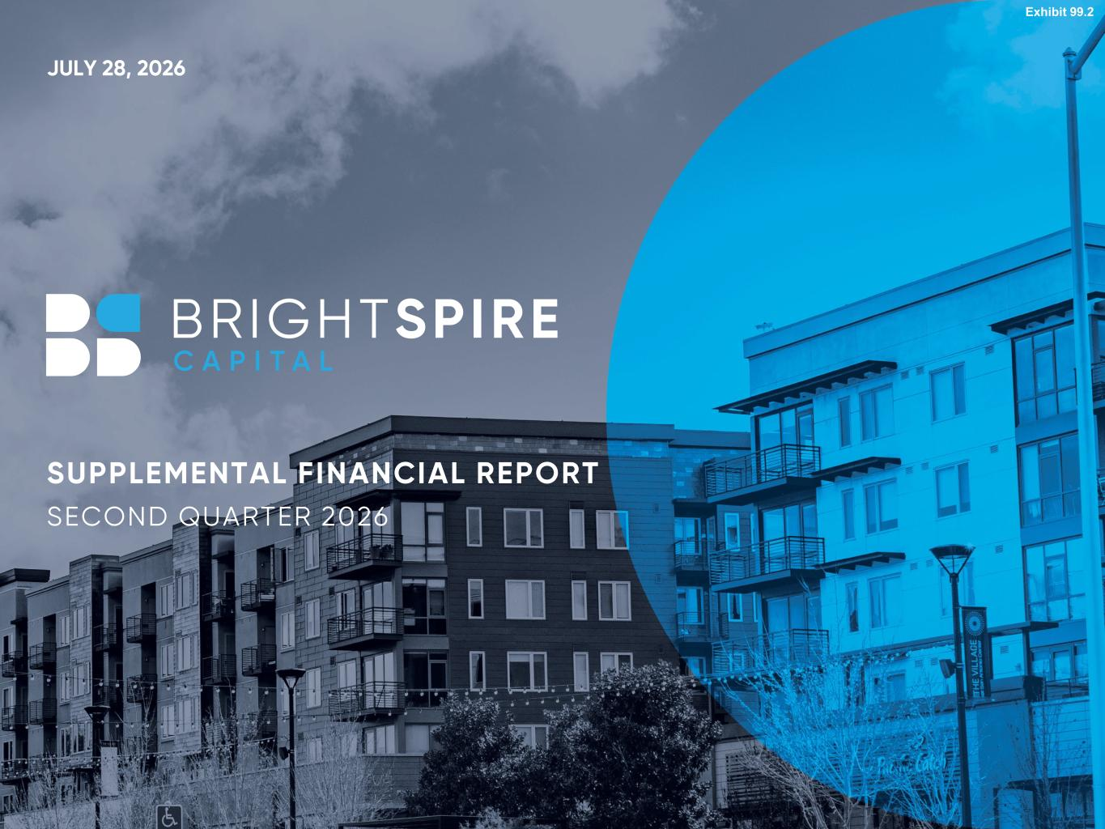
1 JULY 28, 2026 SUPPLEMENTAL FINANCIAL REPORT SECOND QUARTER 2026 Exhibit 99.2


2 CAUTIONARY STATEMENT REGARDING FORWARD-LOOKING STATEMENTS This presentation may contain forward-looking statements within the meaning of the federal securities laws. Forward-looking statements relate to expectations, beliefs, projections, future plans and strategies, anticipated events or trends and similar expressions concerning matters that are not historical facts. In some cases, you can identify forward-looking statements by the use of forward-looking terminology such as “may,” “will,” “should,” “expects,” “intends,” “plans,” “anticipates,” “believes,” “estimates,” “predicts,” or “potential” or the negative of these words and phrases or similar words or phrases which are predictions of or indicate future events or trends and which do not relate solely to historical matters. Forward-looking statements involve known and unknown risks, uncertainties, assumptions and contingencies, many of which are beyond our control, and may cause actual results to differ significantly from those expressed in any forward-looking statement. Among others, the following uncertainties and other factors could cause actual results to differ from those set forth in the forward-looking statements: operating costs and business disruption may be greater than expected; the Company's operating results may differ materially from the information presented in the Company’s Annual Report on Form 10-K for the fiscal year ended December 31, 2025, as well as in the Company’s other filings with the Securities and Exchange Commission; defaults by borrowers in paying debt service on outstanding indebtedness; borrowers’ abilities to manage and stabilize properties; deterioration in the performance of the properties securing our investments (including the impact of higher interest expense, depletion of interest and other reserves or payment-in-kind concessions in lieu of current interest payment obligations, population shifts and migration, reduced demand for office, multifamily, hospitality or retail space) that may cause deterioration in the performance of our investments and, potentially, principal losses to us; the fair value of the Company's investments may be subject to uncertainties (including impacts associated with inflationary trends, the volatility of interest rates and credit spreads, increased market volatility affecting commercial real estate businesses and public securities); the Company's use of leverage and interest rate mismatches between the Company’s assets and borrowings could hinder its ability to make distributions and may significantly impact its liquidity position; the timing of and ability to generate additional liquidity and deploy available liquidity, including in senior mortgage loans; whether the Company will achieve its anticipated Distributable Earnings per share (as adjusted), or maintain or produce higher Distributable Earnings per share (as adjusted) in the near term or ever; the Company’s ability to maintain or grow the dividend at all in the future; adverse impacts on the Company's corporate revolver, including covenant compliance and borrowing base capacity; adverse impacts on the Company's liquidity, including available capacity under and margin calls on master repurchase facilities; lease payment defaults or deferrals, demands for protective advances and capital expenditures; the ability of the Company to refinance certain mortgage debt on similar terms to those currently existing or at all; the ability to execute CRE CLO’s on a go forward basis, including at a reduced cost of capital; whether transactions under letter of intent or contract will close on expected terms, in the expected time period or at all; the impact of legislative, regulatory, tax and competitive changes, regime changes and the actions of government authorities and in particular those affecting the commercial real estate finance and mortgage industry or our business; and the ongoing impacts of global geopolitical uncertainties and unforeseen public health crises on the real estate market. The foregoing list of factors is not exhaustive. Additional information about these and other factors can be found in Part I, Item 1A of the Company’s Annual Report on Form 10-K for the fiscal year ended December 31, 2025, as well as in BrightSpire Capital’s other filings with the Securities and Exchange Commission. We caution investors not to unduly rely on any forward-looking statements. The forward-looking statements speak only as of the date of this presentation. BrightSpire Capital is under no duty to update any of these forward-looking statements after the date of this presentation, nor to conform prior statements to actual results or revised expectations, and BrightSpire Capital does not intend to do so.

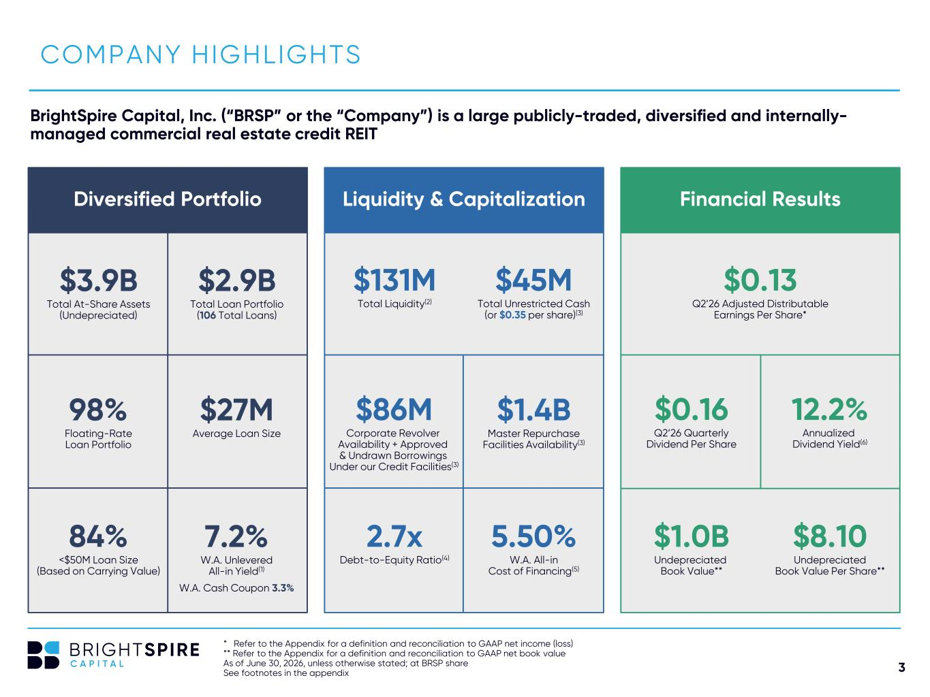
3 Diversified Portfolio Liquidity & Capitalization Financial Results $3.9B Total At-Share Assets (Undepreciated) * Refer to the Appendix for a definition and reconciliation to GAAP net income (loss) ** Refer to the Appendix for a definition and reconciliation to GAAP net book value As of June 30, 2026, unless otherwise stated; at BRSP share See footnotes in the appendix COMPANY HIGHLIGHTS BrightSpire Capital, Inc. (“BRSP” or the “Company”) is a large publicly-traded, diversified and internally- managed commercial real estate credit REIT $2.9B Total Loan Portfolio (106 Total Loans) $27M Average Loan Size 98% Floating-Rate Loan Portfolio $131M Total Liquidity(2) $45M Total Unrestricted Cash (or $0.35 per share)(3) $86M Corporate Revolver Availability + Approved & Undrawn Borrowings Under our Credit Facilities(3) 2.7x Debt-to-Equity Ratio(4) 5.50% W.A. All-in Cost of Financing(5) $1.4B Master Repurchase Facilities Availability(3) 7.2% W.A. Unlevered All-in Yield(1) W.A. Cash Coupon 3.3% 84% <$50M Loan Size (Based on Carrying Value) $0.13 Q2’26 Adjusted Distributable Earnings Per Share* $0.16 Q2’26 Quarterly Dividend Per Share 12.2% Annualized Dividend Yield(6) $1.0B Undepreciated Book Value** $8.10 Undepreciated Book Value Per Share**

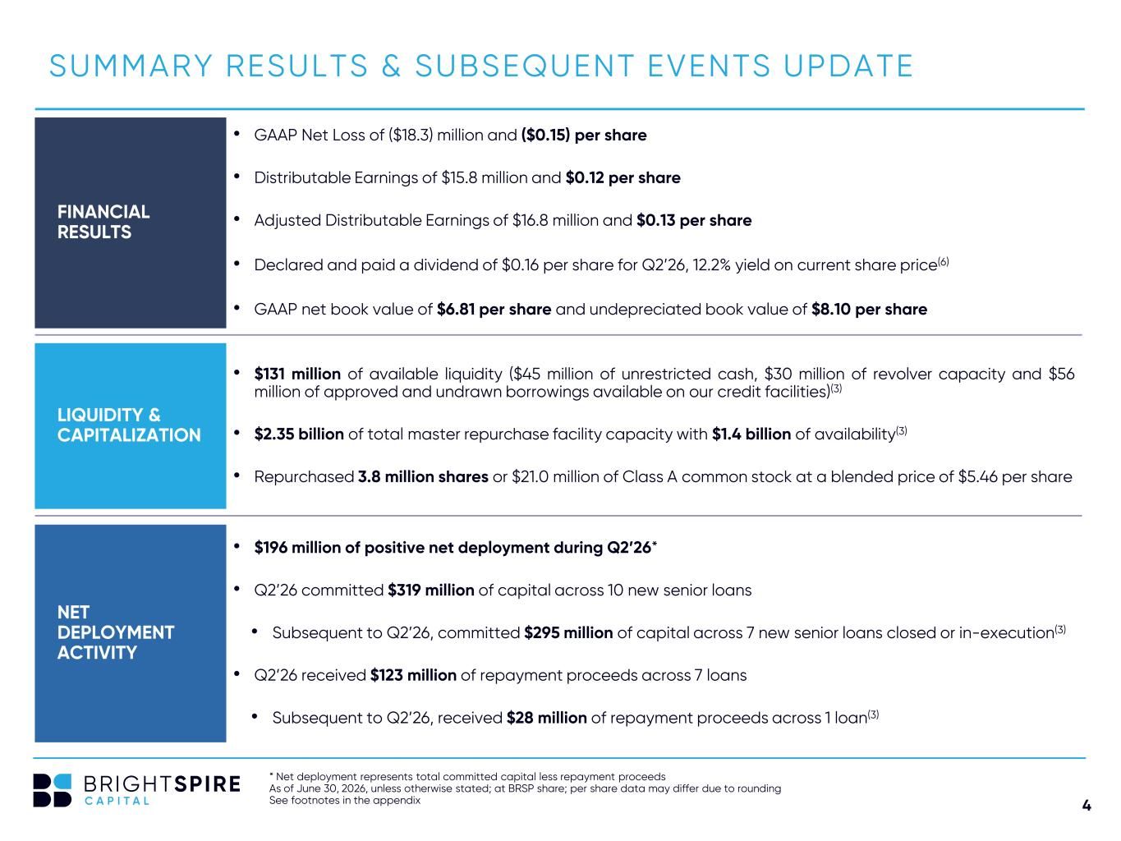
4 SUMMARY RESULTS & SUBSEQUENT EVENTS UPDATE NET DEPLOYMENT ACTIVITY FINANCIAL RESULTS LIQUIDITY & CAPITALIZATION * Net deployment represents total committed capital less repayment proceeds As of June 30, 2026, unless otherwise stated; at BRSP share; per share data may differ due to rounding See footnotes in the appendix • $131 million of available liquidity ($45 million of unrestricted cash, $30 million of revolver capacity and $56 million of approved and undrawn borrowings available on our credit facilities)(3) • $2.35 billion of total master repurchase facility capacity with $1.4 billion of availability(3) • Repurchased 3.8 million shares or $21.0 million of Class A common stock at a blended price of $5.46 per share • GAAP Net Loss of ($18.3) million and ($0.15) per share • Distributable Earnings of $15.8 million and $0.12 per share • Adjusted Distributable Earnings of $16.8 million and $0.13 per share • Declared and paid a dividend of $0.16 per share for Q2’26, 12.2% yield on current share price(6) • GAAP net book value of $6.81 per share and undepreciated book value of $8.10 per share • $196 million of positive net deployment during Q2’26* • Q2’26 committed $319 million of capital across 10 new senior loans • Subsequent to Q2’26, committed $295 million of capital across 7 new senior loans closed or in-execution(3) • Q2’26 received $123 million of repayment proceeds across 7 loans • Subsequent to Q2’26, received $28 million of repayment proceeds across 1 loan(3)

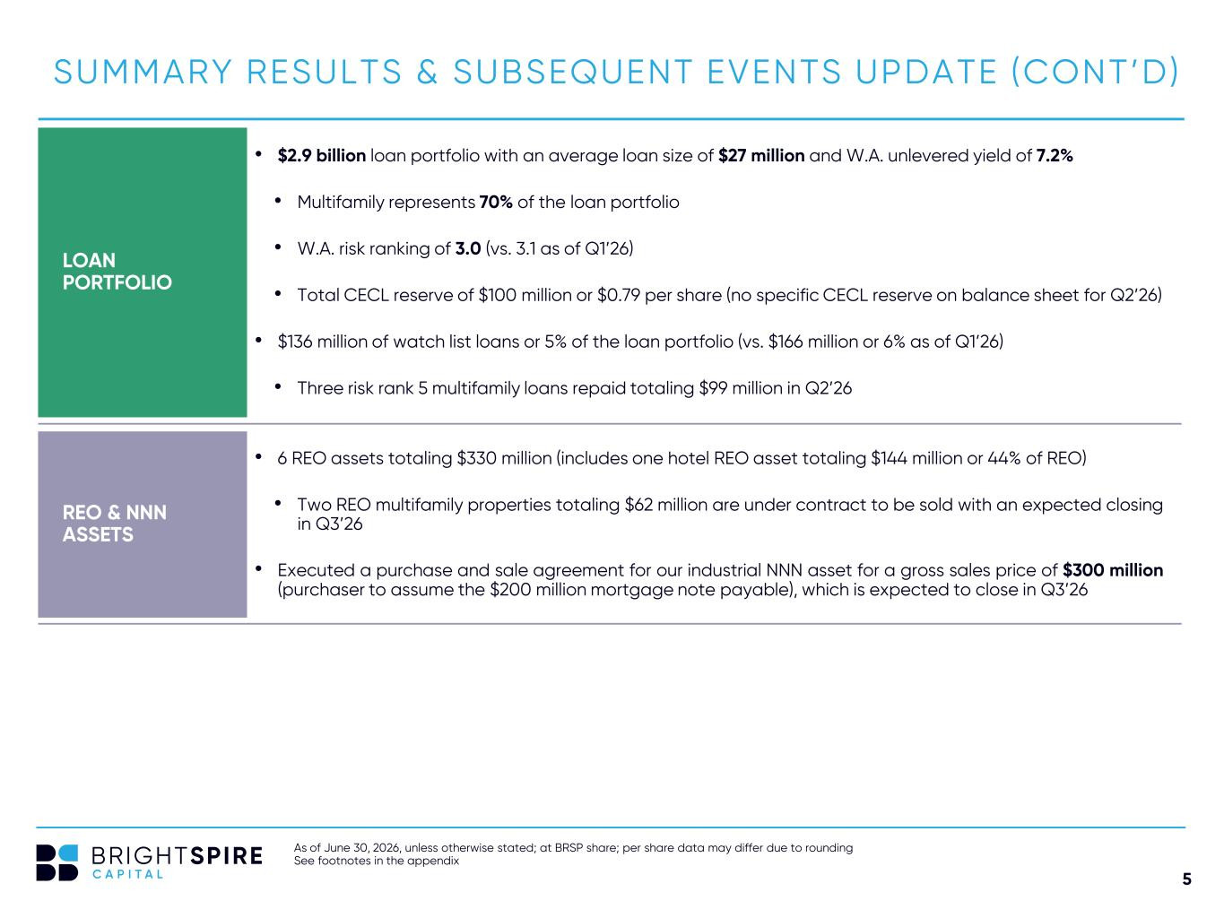
5 SUMMARY RESULTS & SUBSEQUENT EVENTS UPDATE (CONT’D) LOAN PORTFOLIO As of June 30, 2026, unless otherwise stated; at BRSP share; per share data may differ due to rounding See footnotes in the appendix • $2.9 billion loan portfolio with an average loan size of $27 million and W.A. unlevered yield of 7.2% • Multifamily represents 70% of the loan portfolio • W.A. risk ranking of 3.0 (vs. 3.1 as of Q1’26) • Total CECL reserve of $100 million or $0.79 per share (no specific CECL reserve on balance sheet for Q2’26) • $136 million of watch list loans or 5% of the loan portfolio (vs. $166 million or 6% as of Q1’26) • Three risk rank 5 multifamily loans repaid totaling $99 million in Q2’26 • 6 REO assets totaling $330 million (includes one hotel REO asset totaling $144 million or 44% of REO) • Two REO multifamily properties totaling $62 million are under contract to be sold with an expected closing in Q3’26 • Executed a purchase and sale agreement for our industrial NNN asset for a gross sales price of $300 million (purchaser to assume the $200 million mortgage note payable), which is expected to close in Q3’26 REO & NNN ASSETS

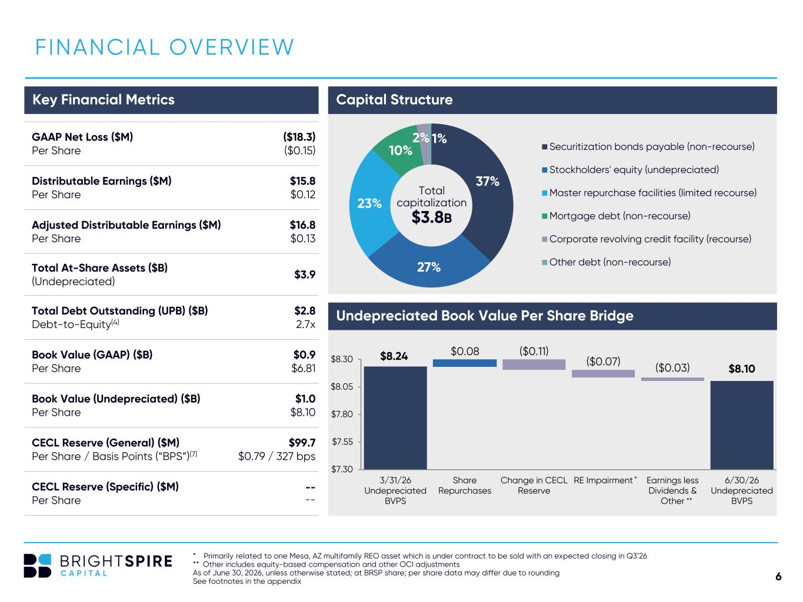
6 $8.24 $8.10 $0.08 ($0.11) ($0.07) ($0.03) $7.30 $7.55 $7.80 $8.05 $8.30 3/31/26 Undepreciated BVPS Share Repurchases Change in CECL Reserve RE Impairment Earnings less Dividends & Other 6/30/26 Undepreciated BVPS 37% 27% 23% 10% 2% 1% Securitization bonds payable (non-recourse) Stockholders' equity (undepreciated) Master repurchase facilities (limited recourse) Mortgage debt (non-recourse) Corporate revolving credit facility (recourse) Other debt (non-recourse) F INANCIAL OVERVIEW * Primarily related to one Mesa, AZ multifamily REO asset which is under contract to be sold with an expected closing in Q3’26 ** Other includes equity-based compensation and other OCI adjustments As of June 30, 2026, unless otherwise stated; at BRSP share; per share data may differ due to rounding See footnotes in the appendix Undepreciated Book Value Per Share Bridge Capital StructureKey Financial Metrics GAAP Net Loss ($M) Per Share ($18.3) ($0.15) Distributable Earnings ($M) Per Share $15.8 $0.12 Adjusted Distributable Earnings ($M) Per Share $16.8 $0.13 Total At-Share Assets ($B) (Undepreciated) $3.9 Total Debt Outstanding (UPB) ($B) Debt-to-Equity(4) $2.8 2.7x Book Value (GAAP) ($B) Per Share $0.9 $6.81 Book Value (Undepreciated) ($B) Per Share $1.0 $8.10 CECL Reserve (General) ($M) Per Share / Basis Points (“BPS”)(7) $99.7 $0.79 / 327 bps CECL Reserve (Specific) ($M) Per Share -- -- Total capitalization $3.8B ** *

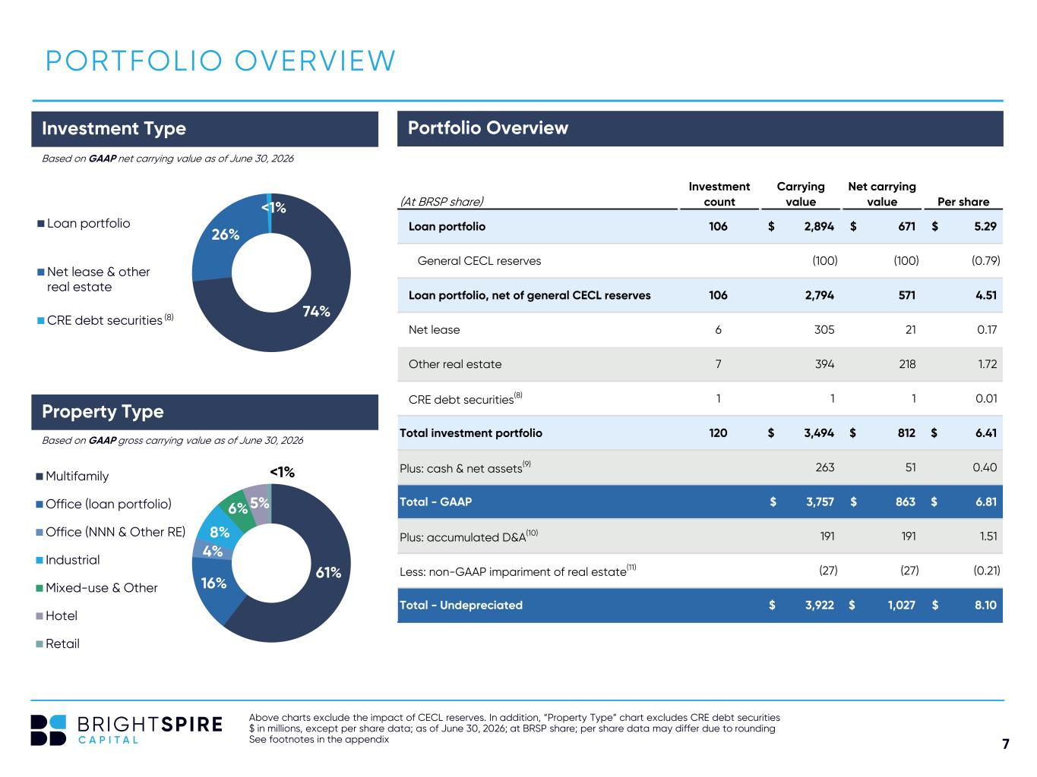
7 74% 26% <1% Loan portfolio Net lease & other real estate CRE debt securities 61% 16% 4% 8% 6%5% <1%Multifamily Office (loan portfolio) Office (NNN & Other RE) Industrial Mixed-use & Other Hotel Retail Above charts exclude the impact of CECL reserves. In addition, “Property Type” chart excludes CRE debt securities $ in millions, except per share data; as of June 30, 2026; at BRSP share; per share data may differ due to rounding See footnotes in the appendix PORTFOLIO OVERVIEW Based on GAAP net carrying value as of June 30, 2026 Based on GAAP gross carrying value as of June 30, 2026 Investment Type Portfolio Overview (8) Property Type (At BRSP share) Investment count Carrying value Net carrying value Per share Loan portfolio 106 2,894$ 671$ 5.29$ General CECL reserves (100) (100) (0.79) Loan portfolio, net of general CECL reserves 106 2,794 571 4.51 Net lease 6 305 21 0.17 Other real estate 7 394 218 1.72 CRE debt securities(8) 1 1 1 0.01 Total investment portfolio 120 3,494$ 812$ 6.41$ Plus: cash & net assets(9) 263 51 0.40 Total - GAAP 3,757$ 863$ 6.81$ Plus: accumulated D&A(10) 191 191 1.51 Less: non-GAAP impariment of real estate(11) (27) (27) (0.21) Total - Undepreciated 3,922$ 1,027$ 8.10$

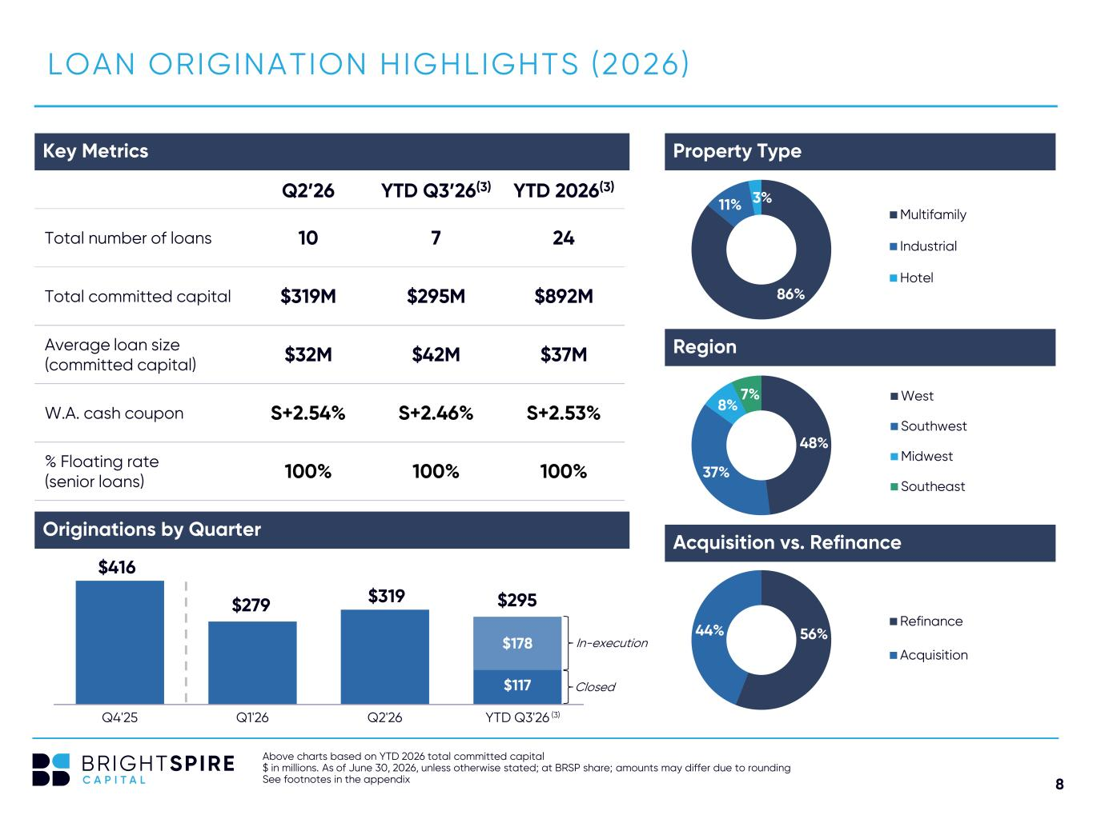
8 LOAN ORIGINATION HIGHLIGHTS (2026) Key Metrics B U D G E T V S . A C T U A L Q2’26 YTD Q3’26(3) YTD 2026(3) Total number of loans 10 7 24 Total committed capital $319M $295M $892M Average loan size (committed capital) $32M $42M $37M W.A. cash coupon S+2.54% S+2.46% S+2.53% % Floating rate (senior loans) 100% 100% 100% Above charts based on YTD 2026 total committed capital $ in millions. As of June 30, 2026, unless otherwise stated; at BRSP share; amounts may differ due to rounding See footnotes in the appendix Property Type Region Acquisition vs. Refinance 86% 11% 3% Multifamily Industrial Hotel 48% 37% 8% 7% West Southwest Midwest Southeast 56%44% Refinance Acquisition $416 $279 $319 $117 $178 Q4'25 Q1'26 Q2'26 YTD Q3'26 Originations by Quarter In-execution $295 Closed (3)

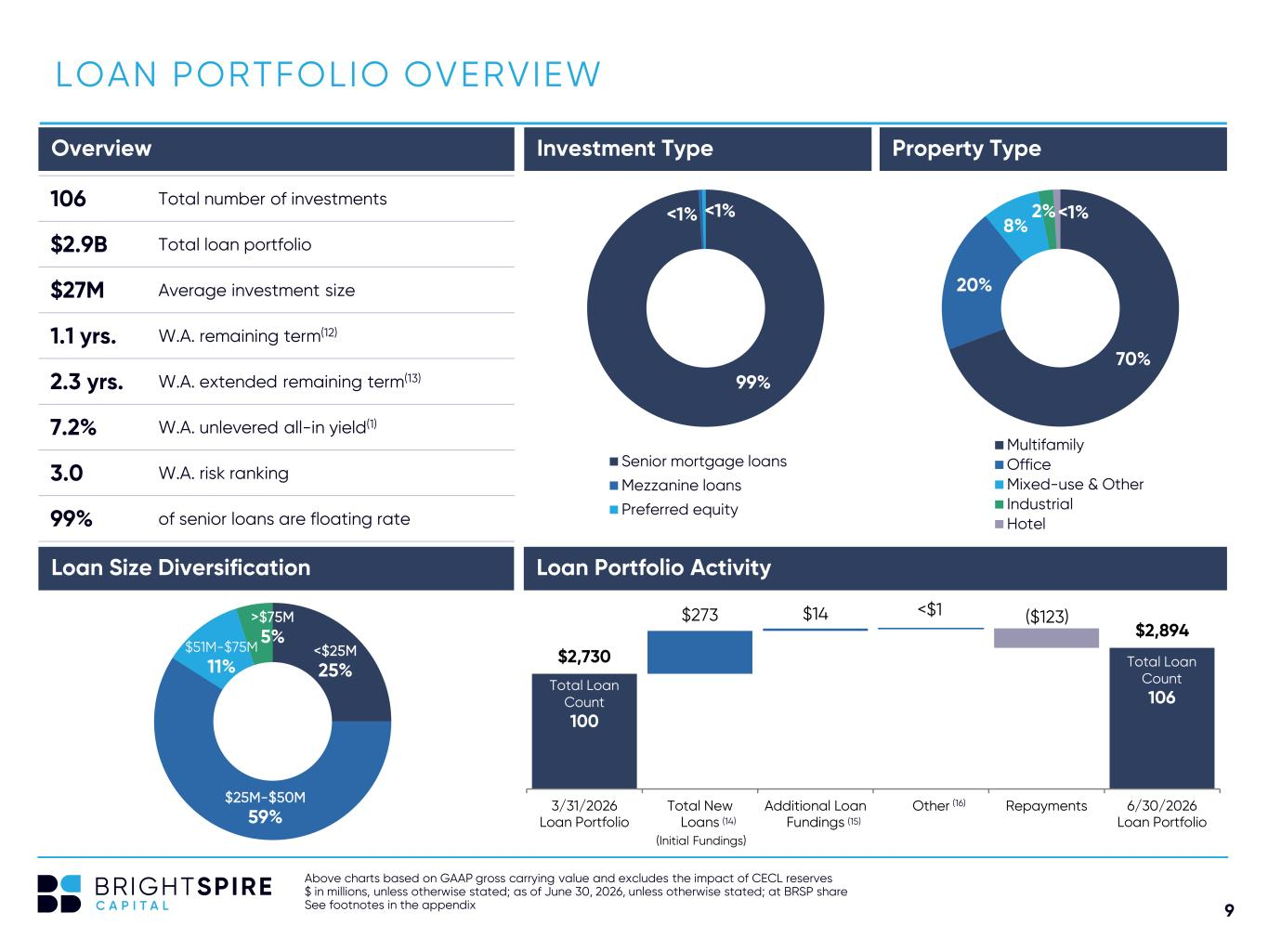
9 $2,730 $2,894 $273 $14 <$1 ($123) 3/31/2026 Loan Portfolio Total New Loans Additional Loan Fundings Other Repayments 6/30/2026 Loan Portfolio <$25M 25% $25M-$50M 59% $51M-$75M 11% >$75M 5% Above charts based on GAAP gross carrying value and excludes the impact of CECL reserves $ in millions, unless otherwise stated; as of June 30, 2026, unless otherwise stated; at BRSP share See footnotes in the appendix LOAN PORTFOLIO OVERVIEW 99% <1% <1% Senior mortgage loans Mezzanine loans Preferred equity Overview Investment Type Property Type 106 Total number of investments $2.9B Total loan portfolio $27M Average investment size 1.1 yrs. W.A. remaining term(12) 2.3 yrs. W.A. extended remaining term(13) 7.2% W.A. unlevered all-in yield(1) 3.0 W.A. risk ranking 99% of senior loans are floating rate 70% 20% 8% 2%<1% Multifamily Office Mixed-use & Other Industrial Hotel Loan Portfolio Activity (16) (15) (Initial Fundings) Loan Size Diversification Total Loan Count 100 Total Loan Count 106 (14)

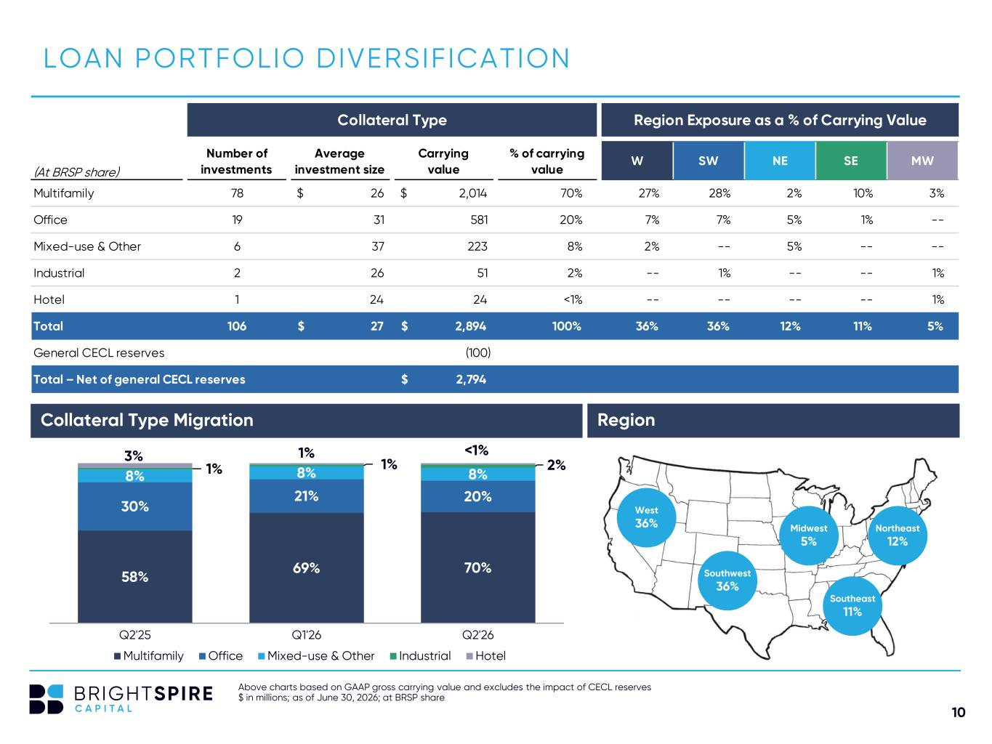
10 Collateral Type Region Exposure as a % of Carrying Value (At BRSP share) Number of investments Average investment size Carrying value % of carrying value W SW NE SE MW Multifamily 78 26$ 2,014$ 70% 27% 28% 2% 10% 3% Office 19 31 581 20% 7% 7% 5% 1% -- Mixed-use & Other 6 37 223 8% 2% -- 5% -- -- Industrial 2 26 51 2% -- 1% -- -- 1% Hotel 1 24 24 <1% -- -- -- -- 1% Total 106 27$ 2,894$ 100% 36% 36% 12% 11% 5% General CECL reserves (100) Total – Net of general CECL reserves 2,794$ Above charts based on GAAP gross carrying value and excludes the impact of CECL reserves $ in millions; as of June 30, 2026; at BRSP share LOAN PORTFOLIO DIVERSIFICATION Northeast 12% Region Southeast 11% Southwest 36% West 36% Midwest 5% Collateral Type Migration 58% 69% 70% 30% 21% 20% 8% 8% 8%1% 1% 2% 3% 1% <1% Q2'25 Q1'26 Q2'26 Multifamily Office Mixed-use & Other Industrial Hotel

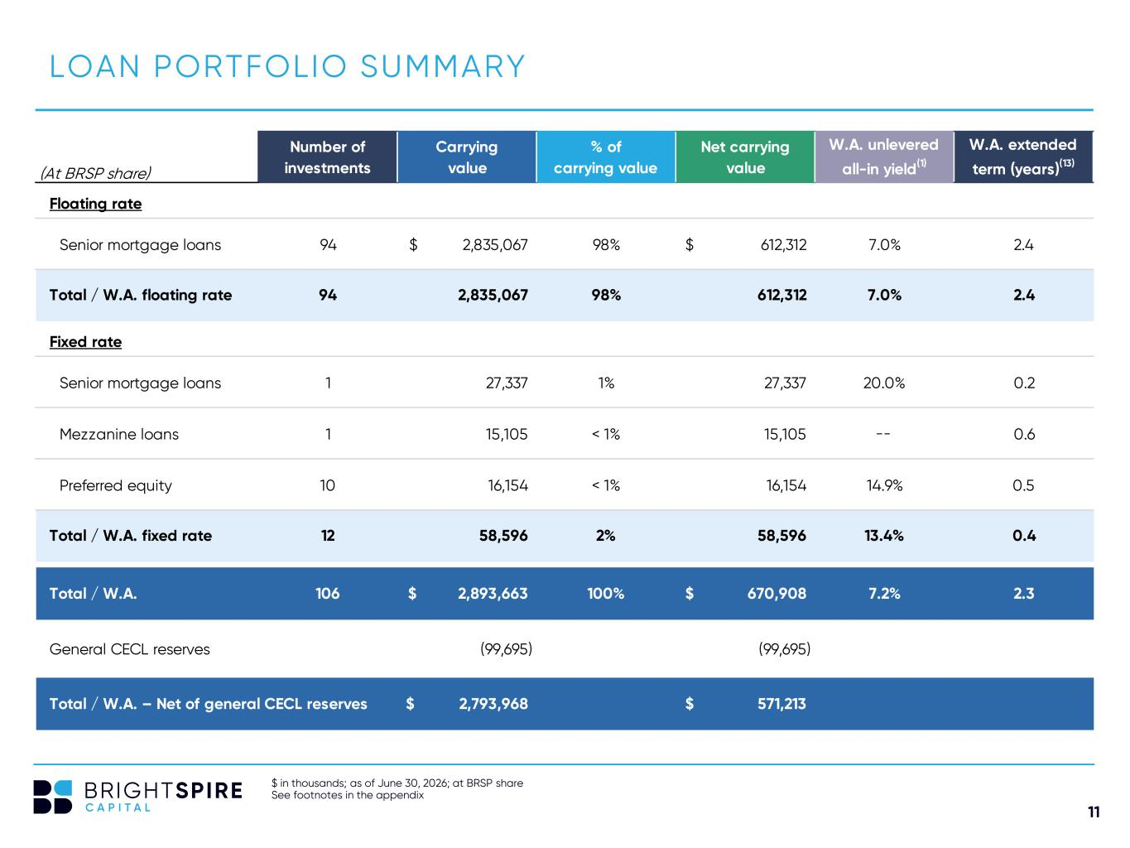
11 (At BRSP share) Number of investments Carrying value % of carrying value Net carrying value W.A. unlevered all-in yield(1) W.A. extended term (years)(13) Floating rate Senior mortgage loans 94 2,835,067$ 98% 612,312$ 7.0% 2.4 Total / W.A. floating rate 94 2,835,067 98% 612,312 7.0% 2.4 Fixed rate Senior mortgage loans 1 27,337 1% 27,337 20.0% 0.2 Mezzanine loans 1 15,105 < 1% 15,105 -- 0.6 Preferred equity 10 16,154 < 1% 16,154 14.9% 0.5 Total / W.A. fixed rate 12 58,596 2% 58,596 13.4% 0.4 Total / W.A. 106 2,893,663$ 100% 670,908$ 7.2% 2.3 General CECL reserves (99,695) (99,695) Total / W.A. – Net of general CECL reserves 2,793,968$ 571,213$ $ in thousands; as of June 30, 2026; at BRSP share See footnotes in the appendix LOAN PORTFOLIO SUMMARY

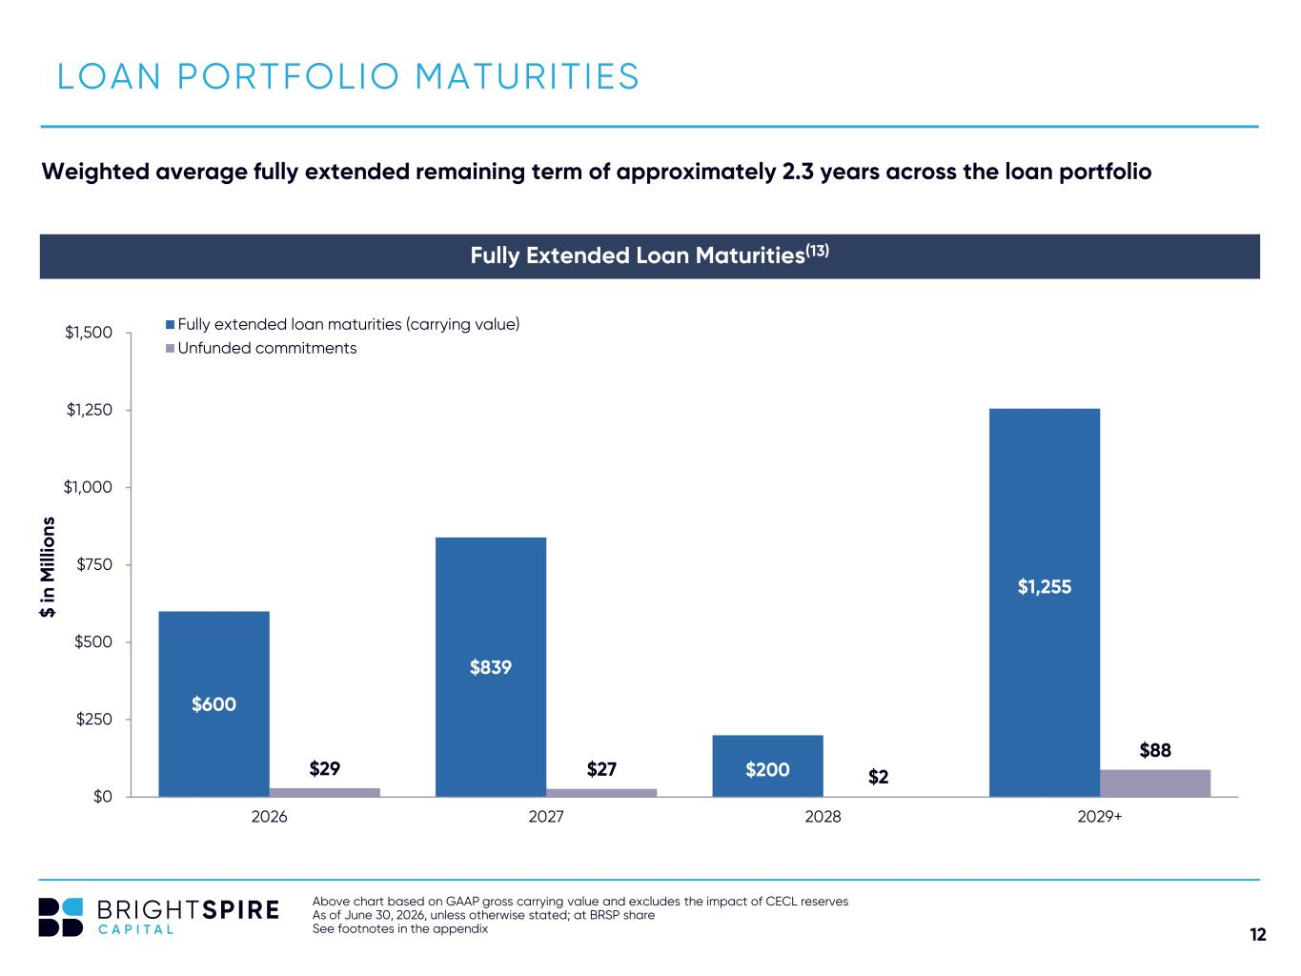
12 LOAN PORTFOLIO MATURITIES Fully Extended Loan Maturities(13) $600 $839 $200 $1,255 $29 $27 $2 $88 $0 $250 $500 $750 $1,000 $1,250 $1,500 2026 2027 2028 2029+ Fully extended loan maturities (carrying value) Unfunded commitments $ in M ill io ns Weighted average fully extended remaining term of approximately 2.3 years across the loan portfolio Above chart based on GAAP gross carrying value and excludes the impact of CECL reserves As of June 30, 2026, unless otherwise stated; at BRSP share See footnotes in the appendix

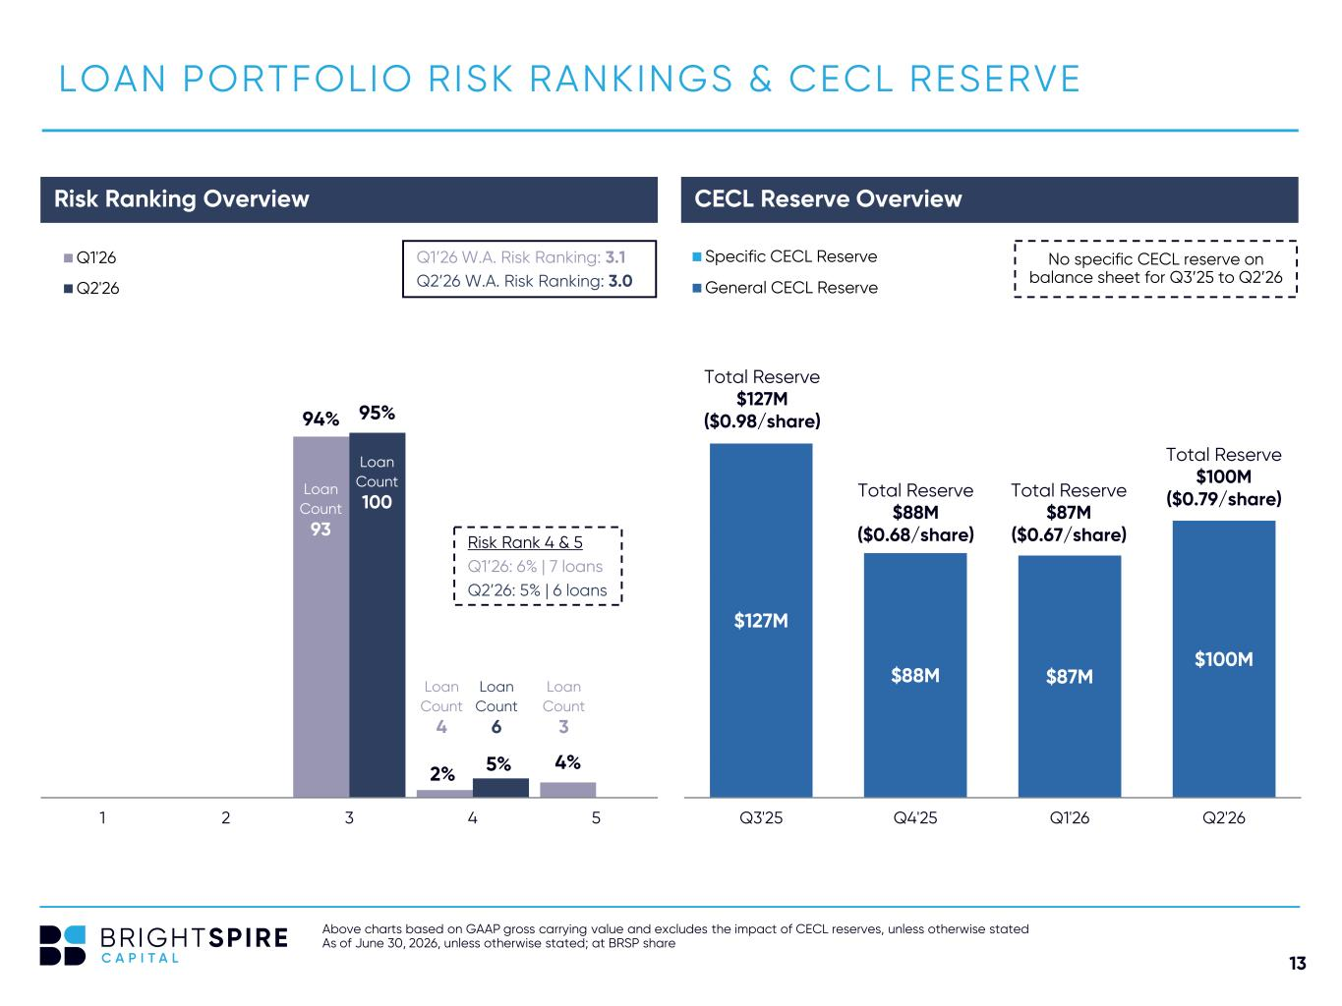
13 94% 2% 4% 95% 5% 1 2 3 4 5 Q1'26 Q2'26 Risk Ranking Overview LOAN PORTFOLIO RISK RANKINGS & CECL RESERVE Above charts based on GAAP gross carrying value and excludes the impact of CECL reserves, unless otherwise stated As of June 30, 2026, unless otherwise stated; at BRSP share CECL Reserve Overview $127M $88M $87M $100M Q3'25 Q4'25 Q1'26 Q2'26 Specific CECL Reserve General CECL Reserve Total Reserve $87M ($0.67/share) Loan Count 93 Loan Count 100 Loan Count 4 Loan Count 6 No specific CECL reserve on balance sheet for Q3’25 to Q2’26 Risk Rank 4 & 5 Q1’26: 6% | 7 loans Q2’26: 5% | 6 loans Q1’26 W.A. Risk Ranking: 3.1 Q2’26 W.A. Risk Ranking: 3.0 Total Reserve $88M ($0.68/share) Total Reserve $127M ($0.98/share) Loan Count 3 Total Reserve $100M ($0.79/share)

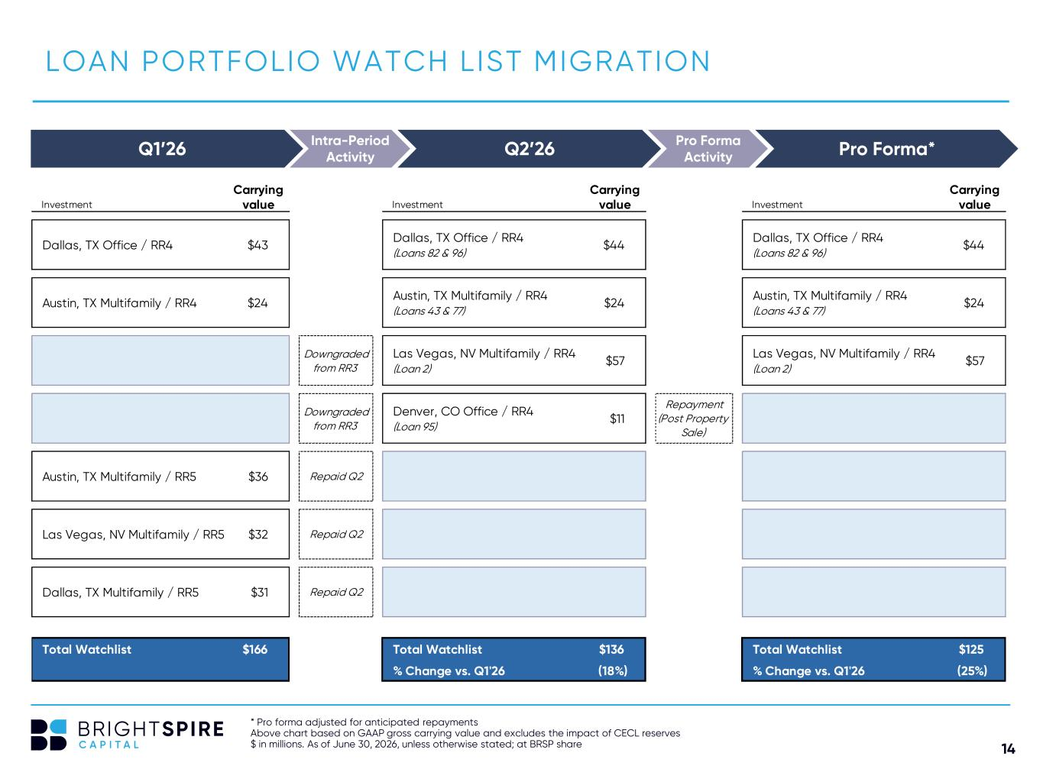
14 Carrying Carrying Carrying Investment value Investment value Investment value Dallas, TX Office / RR4 $43 Dallas, TX Office / RR4 (Loans 82 & 96) $44 Dallas, TX Office / RR4 (Loans 82 & 96) $44 Austin, TX Multifamily / RR4 $24 Austin, TX Multifamily / RR4 (Loans 43 & 77) $24 Austin, TX Multifamily / RR4 (Loans 43 & 77) $24 Downgraded from RR3 Las Vegas, NV Multifamily / RR4 (Loan 2) $57 Las Vegas, NV Multifamily / RR4 (Loan 2) $57 Downgraded from RR3 Denver, CO Office / RR4 (Loan 95) $11 Repayment (Post Property Sale) Austin, TX Multifamily / RR5 $36 Repaid Q2 Las Vegas, NV Multifamily / RR5 $32 Repaid Q2 Dallas, TX Multifamily / RR5 $31 Repaid Q2 Total Watchlist $166 Total Watchlist $136 Total Watchlist $125 % Change vs. Q1'26 (18%) % Change vs. Q1'26 (25%) LOAN PORTFOLIO WATCH LIST MIGRATION * Pro forma adjusted for anticipated repayments Above chart based on GAAP gross carrying value and excludes the impact of CECL reserves $ in millions. As of June 30, 2026, unless otherwise stated; at BRSP share Q1’26 Q2’26 Pro Forma*Pro Forma Activity Intra-Period Activity

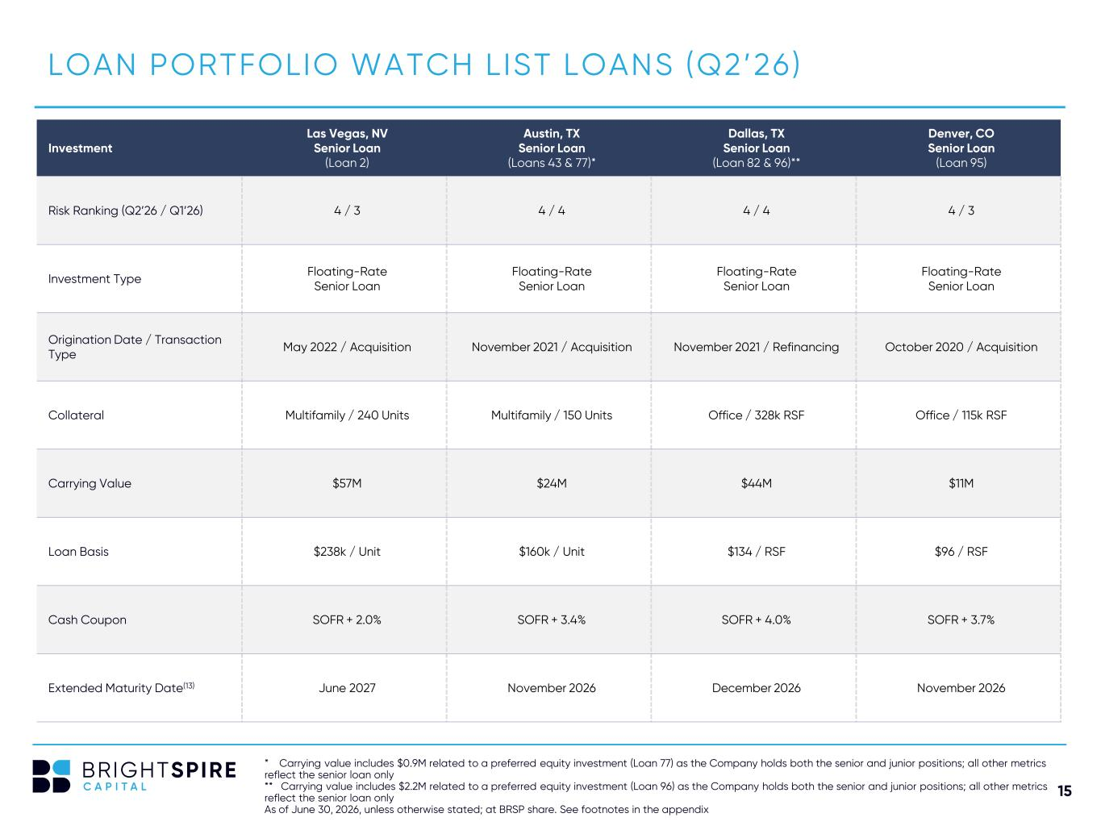
15 LOAN PORTFOLIO WATCH LIST LOANS (Q2’26) * Carrying value includes $0.9M related to a preferred equity investment (Loan 77) as the Company holds both the senior and junior positions; all other metrics reflect the senior loan only ** Carrying value includes $2.2M related to a preferred equity investment (Loan 96) as the Company holds both the senior and junior positions; all other metrics reflect the senior loan only As of June 30, 2026, unless otherwise stated; at BRSP share. See footnotes in the appendix Investment Las Vegas, NV Senior Loan (Loan 2) Austin, TX Senior Loan (Loans 43 & 77)* Dallas, TX Senior Loan (Loan 82 & 96)** Denver, CO Senior Loan (Loan 95) Risk Ranking (Q2’26 / Q1’26) 4 / 3 4 / 4 4 / 4 4 / 3 Investment Type Floating-Rate Senior Loan Floating-Rate Senior Loan Floating-Rate Senior Loan Floating-Rate Senior Loan Origination Date / Transaction Type May 2022 / Acquisition November 2021 / Acquisition November 2021 / Refinancing October 2020 / Acquisition Collateral Multifamily / 240 Units Multifamily / 150 Units Office / 328k RSF Office / 115k RSF Carrying Value $57M $24M $44M $11M Loan Basis $238k / Unit $160k / Unit $134 / RSF $96 / RSF Cash Coupon SOFR + 2.0% SOFR + 3.4% SOFR + 4.0% SOFR + 3.7% Extended Maturity Date(13) June 2027 November 2026 December 2026 November 2026

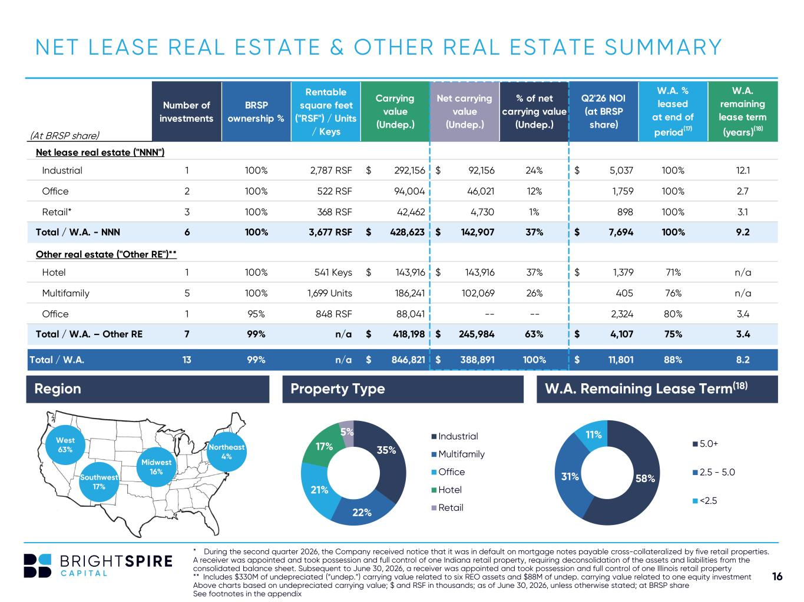
16 (At BRSP share) Number of investments BRSP ownership % Rentable square feet ("RSF") / Units / Keys Carrying value (Undep.) Net carrying value (Undep.) % of net carrying value (Undep.) Q2'26 NOI (at BRSP share) W.A. % leased at end of period(17) W.A. remaining lease term (years)(18) Net lease real estate ("NNN") Industrial 1 100% 2,787 RSF 292,156$ 92,156$ 24% 5,037$ 100% 12.1 Office 2 100% 522 RSF 94,004 46,021 12% 1,759 100% 2.7 Retail* 3 100% 368 RSF 42,462 4,730 1% 898 100% 3.1 Total / W.A. - NNN 6 100% 3,677 RSF 428,623$ 142,907$ 37% 7,694$ 100% 9.2 Other real estate ("Other RE")** Hotel 1 100% 541 Keys 143,916$ 143,916$ 37% 1,379$ 71% n/a Multifamily 5 100% 1,699 Units 186,241 102,069 26% 405 76% n/a Office 1 95% 848 RSF 88,041 -- -- 2,324 80% 3.4 Total / W.A. – Other RE 7 99% n/a 418,198$ 245,984$ 63% 4,107$ 75% 3.4 Total / W.A. 13 99% n/a 846,821$ 388,891$ 100% 11,801$ 88% 8.2 35% 22% 21% 17% 5% Industrial Multifamily Office Hotel Retail NET LEASE REAL ESTATE & OTHER REAL ESTATE SUMMARY 58%31% 11% 5.0+ 2.5 - 5.0 <2.5 Region Property Type W.A. Remaining Lease Term(18) West 63% Northeast 4% Midwest 16% Southwest 17% * During the second quarter 2026, the Company received notice that it was in default on mortgage notes payable cross-collateralized by five retail properties. A receiver was appointed and took possession and full control of one Indiana retail property, requiring deconsolidation of the assets and liabilities from the consolidated balance sheet. Subsequent to June 30, 2026, a receiver was appointed and took possession and full control of one Illinois retail property ** Includes $330M of undepreciated (“undep.”) carrying value related to six REO assets and $88M of undep. carrying value related to one equity investment Above charts based on undepreciated carrying value; $ and RSF in thousands; as of June 30, 2026, unless otherwise stated; at BRSP share See footnotes in the appendix

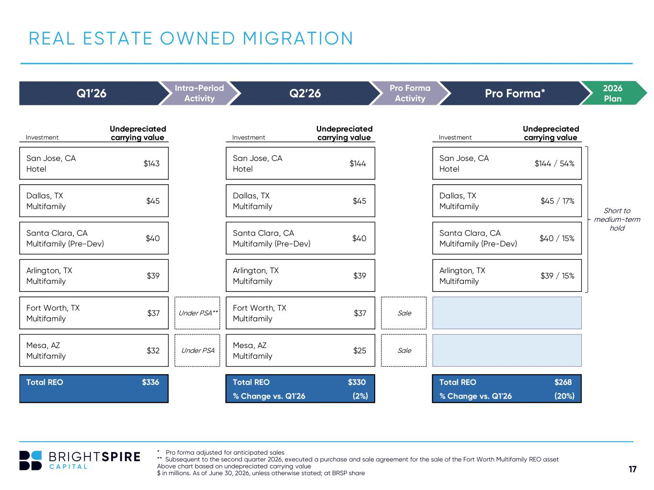
17 Undepreciated Undepreciated Undepreciated Investment carrying value Investment carrying value Investment carrying value San Jose, CA Hotel $143 San Jose, CA Hotel $144 San Jose, CA Hotel $144 / 54% Dallas, TX Multifamily $45 Dallas, TX Multifamily $45 Dallas, TX Multifamily $45 / 17% Santa Clara, CA Multifamily (Pre-Dev) $40 Santa Clara, CA Multifamily (Pre-Dev) $40 Santa Clara, CA Multifamily (Pre-Dev) $40 / 15% Arlington, TX Multifamily $39 Arlington, TX Multifamily $39 Arlington, TX Multifamily $39 / 15% Fort Worth, TX Multifamily $37 Under PSA** Fort Worth, TX Multifamily $37 Sale Mesa, AZ Multifamily $32 Under PSA Mesa, AZ Multifamily $25 Sale Total REO $336 Total REO $330 Total REO $268 % Change vs. Q1'26 (2%) % Change vs. Q1'26 (20%) REAL ESTATE OWNED MIGRATION * Pro forma adjusted for anticipated sales ** Subsequent to the second quarter 2026, executed a purchase and sale agreement for the sale of the Fort Worth Multifamily REO asset Above chart based on undepreciated carrying value $ in millions. As of June 30, 2026, unless otherwise stated; at BRSP share Q1’26 Q2’26 Pro Forma*Pro Forma Activity Intra-Period Activity Short to medium-term hold 2026 Plan

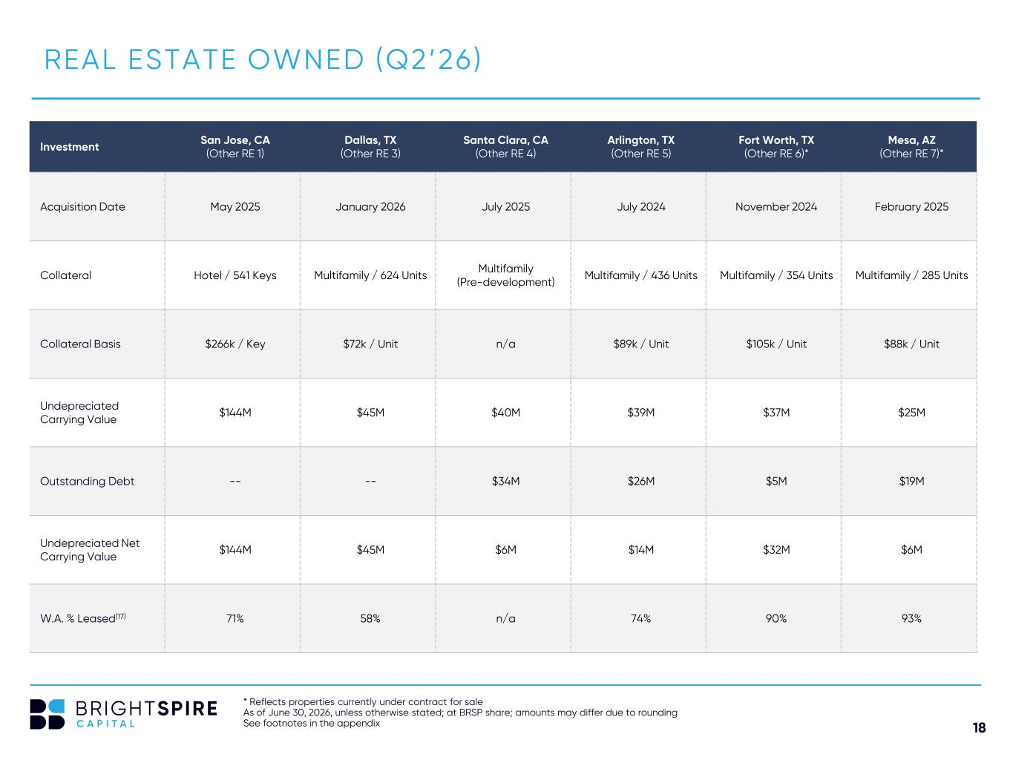
18 Investment San Jose, CA (Other RE 1) Dallas, TX (Other RE 3) Santa Clara, CA (Other RE 4) Arlington, TX (Other RE 5) Fort Worth, TX (Other RE 6)* Mesa, AZ (Other RE 7)* Acquisition Date May 2025 January 2026 July 2025 July 2024 November 2024 February 2025 Collateral Hotel / 541 Keys Multifamily / 624 Units Multifamily (Pre-development) Multifamily / 436 Units Multifamily / 354 Units Multifamily / 285 Units Collateral Basis $266k / Key $72k / Unit n/a $89k / Unit $105k / Unit $88k / Unit Undepreciated Carrying Value $144M $45M $40M $39M $37M $25M Outstanding Debt -- -- $34M $26M $5M $19M Undepreciated Net Carrying Value $144M $45M $6M $14M $32M $6M W.A. % Leased(17) 71% 58% n/a 74% 90% 93% REAL ESTATE OWNED (Q2’26) * Reflects properties currently under contract for sale As of June 30, 2026, unless otherwise stated; at BRSP share; amounts may differ due to rounding See footnotes in the appendix

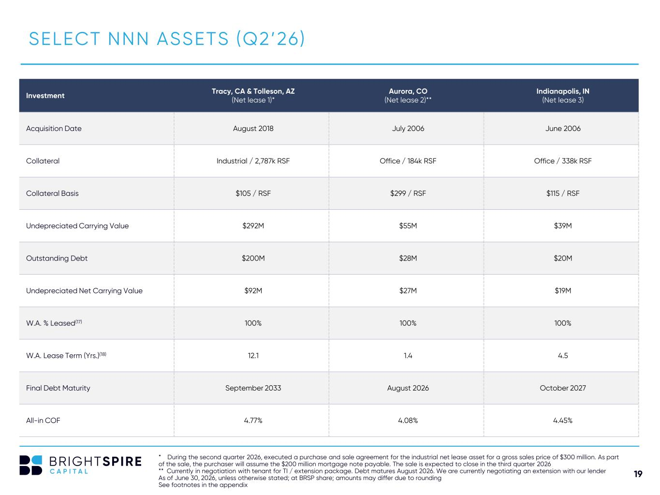
19 SELECT NNN ASSETS (Q2’26) * During the second quarter 2026, executed a purchase and sale agreement for the industrial net lease asset for a gross sales price of $300 million. As part of the sale, the purchaser will assume the $200 million mortgage note payable. The sale is expected to close in the third quarter 2026 ** Currently in negotiation with tenant for TI / extension package. Debt matures August 2026. We are currently negotiating an extension with our lender As of June 30, 2026, unless otherwise stated; at BRSP share; amounts may differ due to rounding See footnotes in the appendix Investment Tracy, CA & Tolleson, AZ (Net lease 1)* Aurora, CO (Net lease 2)** Indianapolis, IN (Net lease 3) Acquisition Date August 2018 July 2006 June 2006 Collateral Industrial / 2,787k RSF Office / 184k RSF Office / 338k RSF Collateral Basis $105 / RSF $299 / RSF $115 / RSF Undepreciated Carrying Value $292M $55M $39M Outstanding Debt $200M $28M $20M Undepreciated Net Carrying Value $92M $27M $19M W.A. % Leased(17) 100% 100% 100% W.A. Lease Term (Yrs.)(18) 12.1 1.4 4.5 Final Debt Maturity September 2033 August 2026 October 2027 All-in COF 4.77% 4.08% 4.45%

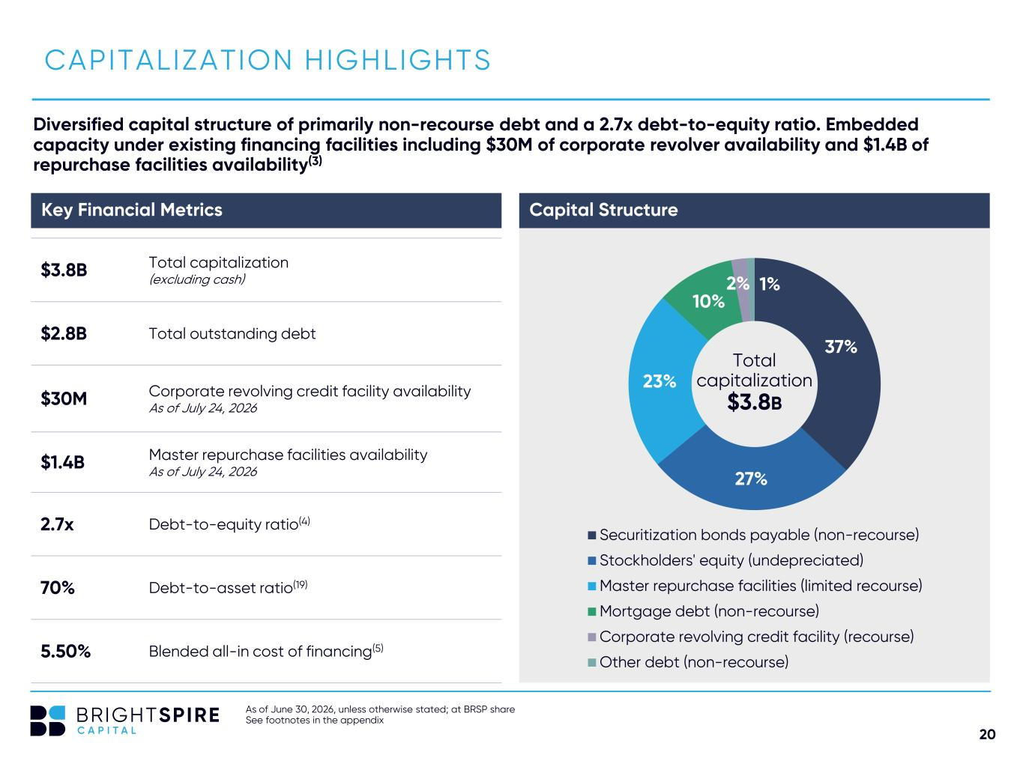
20 As of June 30, 2026, unless otherwise stated; at BRSP share See footnotes in the appendix CAPITALIZATION HIGHLIGHTS Diversified capital structure of primarily non-recourse debt and a 2.7x debt-to-equity ratio. Embedded capacity under existing financing facilities including $30M of corporate revolver availability and $1.4B of repurchase facilities availability(3) 37% 27% 23% 10% 2% 1% Securitization bonds payable (non-recourse) Stockholders' equity (undepreciated) Master repurchase facilities (limited recourse) Mortgage debt (non-recourse) Corporate revolving credit facility (recourse) Other debt (non-recourse) $3.8B Total capitalization (excluding cash) $2.8B Total outstanding debt $30M Corporate revolving credit facility availability As of July 24, 2026 $1.4B Master repurchase facilities availability As of July 24, 2026 2.7x Debt-to-equity ratio(4) 70% Debt-to-asset ratio(19) 5.50% Blended all-in cost of financing(5) Capital StructureKey Financial Metrics Total capitalization $3.8B

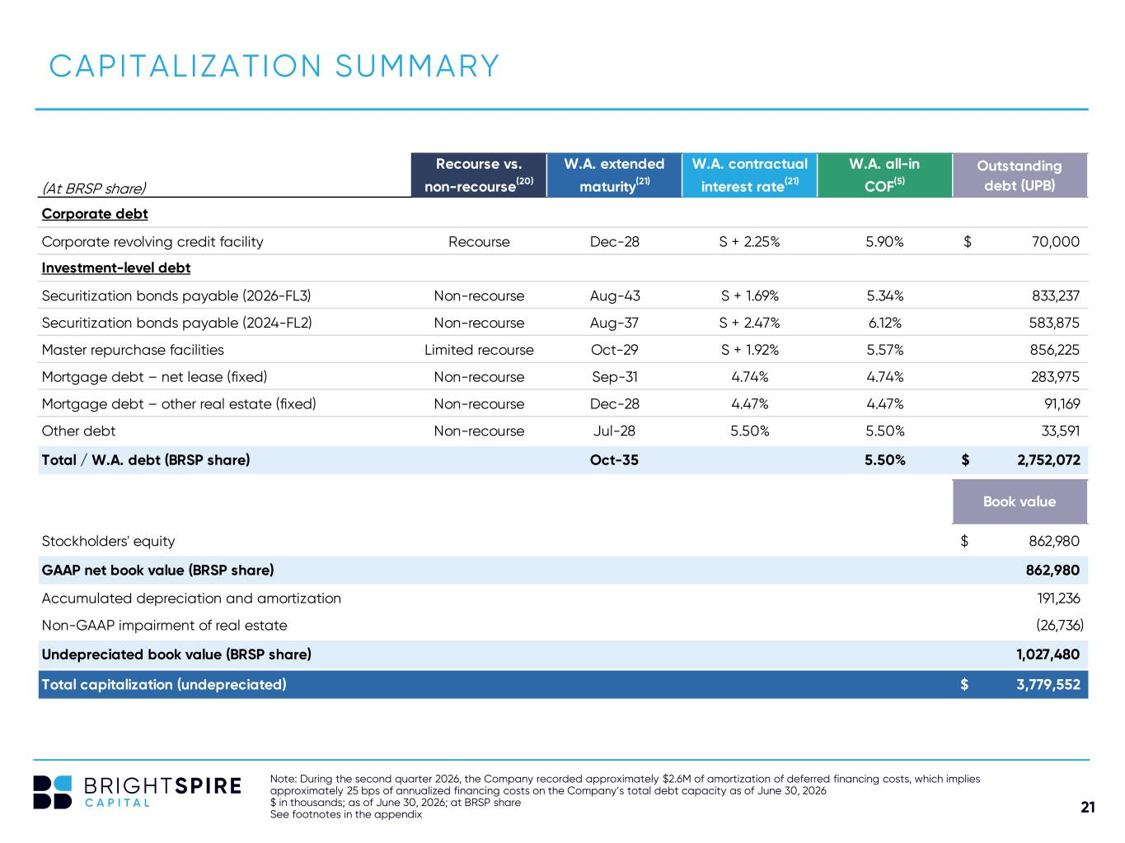
21 (At BRSP share) Recourse vs. non-recourse(20) W.A. extended maturity(21) W.A. contractual interest rate(21) W.A. all-in COF(5) Outstanding debt (UPB) Corporate debt Corporate revolving credit facility Recourse Dec-28 S + 2.25% 5.90% 70,000$ Investment-level debt Securitization bonds payable (2026-FL3) Non-recourse Aug-43 S + 1.69% 5.34% 833,237 Securitization bonds payable (2024-FL2) Non-recourse Aug-37 S + 2.47% 6.12% 583,875 Master repurchase facilities Limited recourse Oct-29 S + 1.92% 5.57% 856,225 Mortgage debt – net lease (fixed) Non-recourse Sep-31 4.74% 4.74% 283,975 Mortgage debt – other real estate (fixed) Non-recourse Dec-28 4.47% 4.47% 91,169 Other debt Non-recourse Jul-28 5.50% 5.50% 33,591 Total / W.A. debt (BRSP share) Oct-35 5.50% 2,752,072$ Book value Stockholders' equity 862,980$ GAAP net book value (BRSP share) 862,980 Accumulated depreciation and amortization 191,236 Non-GAAP impairment of real estate (26,736) Undepreciated book value (BRSP share) 1,027,480 Total capitalization (undepreciated) 3,779,552$ Note: During the second quarter 2026, the Company recorded approximately $2.6M of amortization of deferred financing costs, which implies approximately 25 bps of annualized financing costs on the Company’s total debt capacity as of June 30, 2026 $ in thousands; as of June 30, 2026; at BRSP share See footnotes in the appendix CAPITALIZATION SUMMARY

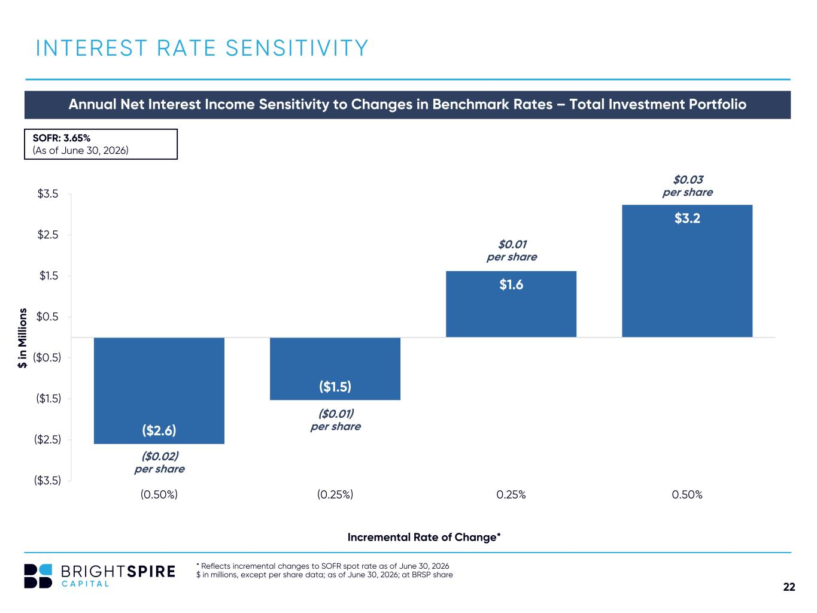
22 ($2.6) ($1.5) $1.6 $3.2 ($3.5) ($2.5) ($1.5) ($0.5) $0.5 $1.5 $2.5 $3.5 (0.50%) (0.25%) 0.25% 0.50% * Reflects incremental changes to SOFR spot rate as of June 30, 2026 $ in millions, except per share data; as of June 30, 2026; at BRSP share INTEREST RATE SENSITIVITY Annual Net Interest Income Sensitivity to Changes in Benchmark Rates – Total Investment Portfolio $ in M ill io ns SOFR: 3.65% (As of June 30, 2026) Incremental Rate of Change* ($0.01) per share $0.01 per share $0.03 per share ($0.02) per share


23 APPENDIX

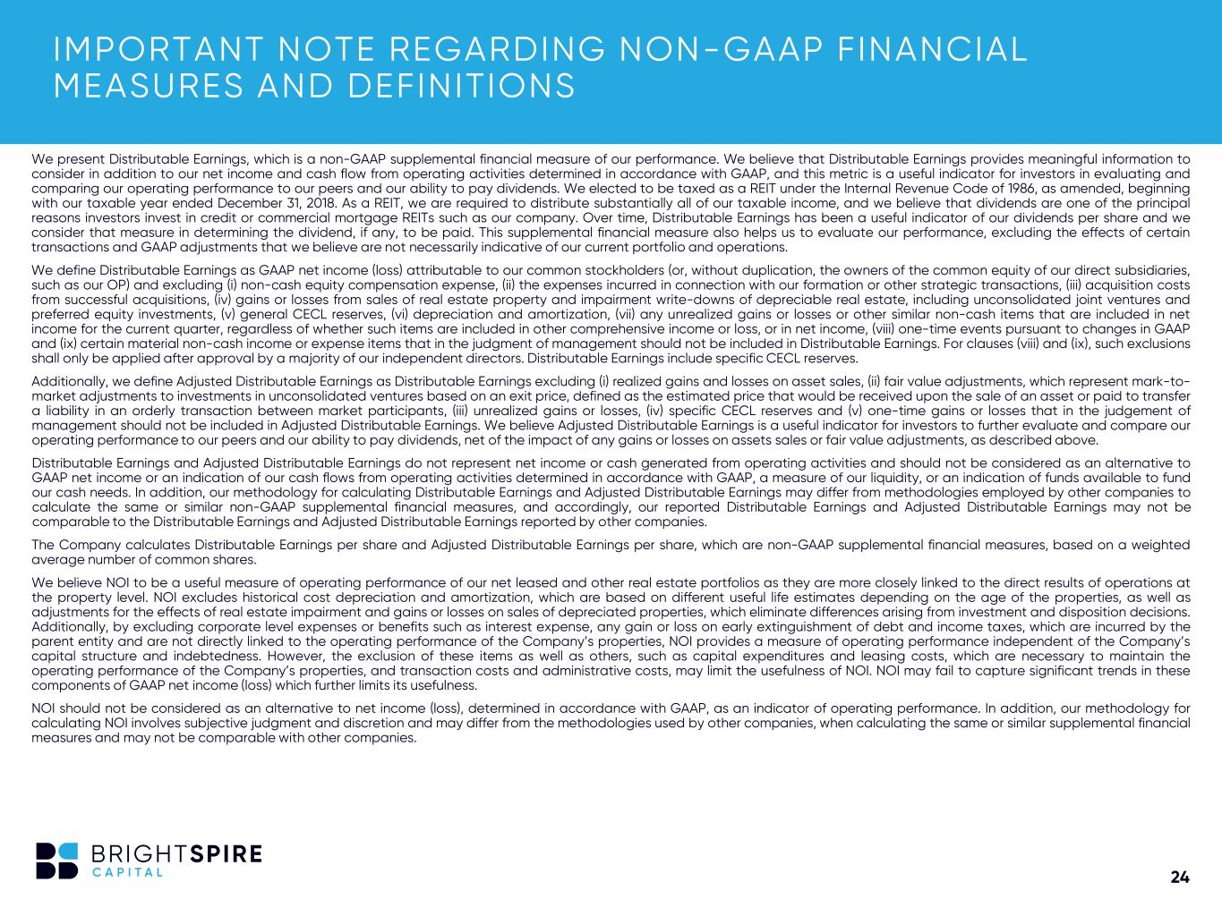
24 IMPORTANT NOTE REGARDING NON-GAAP FINANCIAL MEASURES AND DEFINITIONS We present Distributable Earnings, which is a non-GAAP supplemental financial measure of our performance. We believe that Distributable Earnings provides meaningful information to consider in addition to our net income and cash flow from operating activities determined in accordance with GAAP, and this metric is a useful indicator for investors in evaluating and comparing our operating performance to our peers and our ability to pay dividends. We elected to be taxed as a REIT under the Internal Revenue Code of 1986, as amended, beginning with our taxable year ended December 31, 2018. As a REIT, we are required to distribute substantially all of our taxable income, and we believe that dividends are one of the principal reasons investors invest in credit or commercial mortgage REITs such as our company. Over time, Distributable Earnings has been a useful indicator of our dividends per share and we consider that measure in determining the dividend, if any, to be paid. This supplemental financial measure also helps us to evaluate our performance, excluding the effects of certain transactions and GAAP adjustments that we believe are not necessarily indicative of our current portfolio and operations. We define Distributable Earnings as GAAP net income (loss) attributable to our common stockholders (or, without duplication, the owners of the common equity of our direct subsidiaries, such as our OP) and excluding (i) non-cash equity compensation expense, (ii) the expenses incurred in connection with our formation or other strategic transactions, (iii) acquisition costs from successful acquisitions, (iv) gains or losses from sales of real estate property and impairment write-downs of depreciable real estate, including unconsolidated joint ventures and preferred equity investments, (v) general CECL reserves, (vi) depreciation and amortization, (vii) any unrealized gains or losses or other similar non-cash items that are included in net income for the current quarter, regardless of whether such items are included in other comprehensive income or loss, or in net income, (viii) one-time events pursuant to changes in GAAP and (ix) certain material non-cash income or expense items that in the judgment of management should not be included in Distributable Earnings. For clauses (viii) and (ix), such exclusions shall only be applied after approval by a majority of our independent directors. Distributable Earnings include specific CECL reserves. Additionally, we define Adjusted Distributable Earnings as Distributable Earnings excluding (i) realized gains and losses on asset sales, (ii) fair value adjustments, which represent mark-to- market adjustments to investments in unconsolidated ventures based on an exit price, defined as the estimated price that would be received upon the sale of an asset or paid to transfer a liability in an orderly transaction between market participants, (iii) unrealized gains or losses, (iv) specific CECL reserves and (v) one-time gains or losses that in the judgement of management should not be included in Adjusted Distributable Earnings. We believe Adjusted Distributable Earnings is a useful indicator for investors to further evaluate and compare our operating performance to our peers and our ability to pay dividends, net of the impact of any gains or losses on assets sales or fair value adjustments, as described above. Distributable Earnings and Adjusted Distributable Earnings do not represent net income or cash generated from operating activities and should not be considered as an alternative to GAAP net income or an indication of our cash flows from operating activities determined in accordance with GAAP, a measure of our liquidity, or an indication of funds available to fund our cash needs. In addition, our methodology for calculating Distributable Earnings and Adjusted Distributable Earnings may differ from methodologies employed by other companies to calculate the same or similar non-GAAP supplemental financial measures, and accordingly, our reported Distributable Earnings and Adjusted Distributable Earnings may not be comparable to the Distributable Earnings and Adjusted Distributable Earnings reported by other companies. The Company calculates Distributable Earnings per share and Adjusted Distributable Earnings per share, which are non-GAAP supplemental financial measures, based on a weighted average number of common shares. We believe NOI to be a useful measure of operating performance of our net leased and other real estate portfolios as they are more closely linked to the direct results of operations at the property level. NOI excludes historical cost depreciation and amortization, which are based on different useful life estimates depending on the age of the properties, as well as adjustments for the effects of real estate impairment and gains or losses on sales of depreciated properties, which eliminate differences arising from investment and disposition decisions. Additionally, by excluding corporate level expenses or benefits such as interest expense, any gain or loss on early extinguishment of debt and income taxes, which are incurred by the parent entity and are not directly linked to the operating performance of the Company’s properties, NOI provides a measure of operating performance independent of the Company’s capital structure and indebtedness. However, the exclusion of these items as well as others, such as capital expenditures and leasing costs, which are necessary to maintain the operating performance of the Company’s properties, and transaction costs and administrative costs, may limit the usefulness of NOI. NOI may fail to capture significant trends in these components of GAAP net income (loss) which further limits its usefulness. NOI should not be considered as an alternative to net income (loss), determined in accordance with GAAP, as an indicator of operating performance. In addition, our methodology for calculating NOI involves subjective judgment and discretion and may differ from the methodologies used by other companies, when calculating the same or similar supplemental financial measures and may not be comparable with other companies.

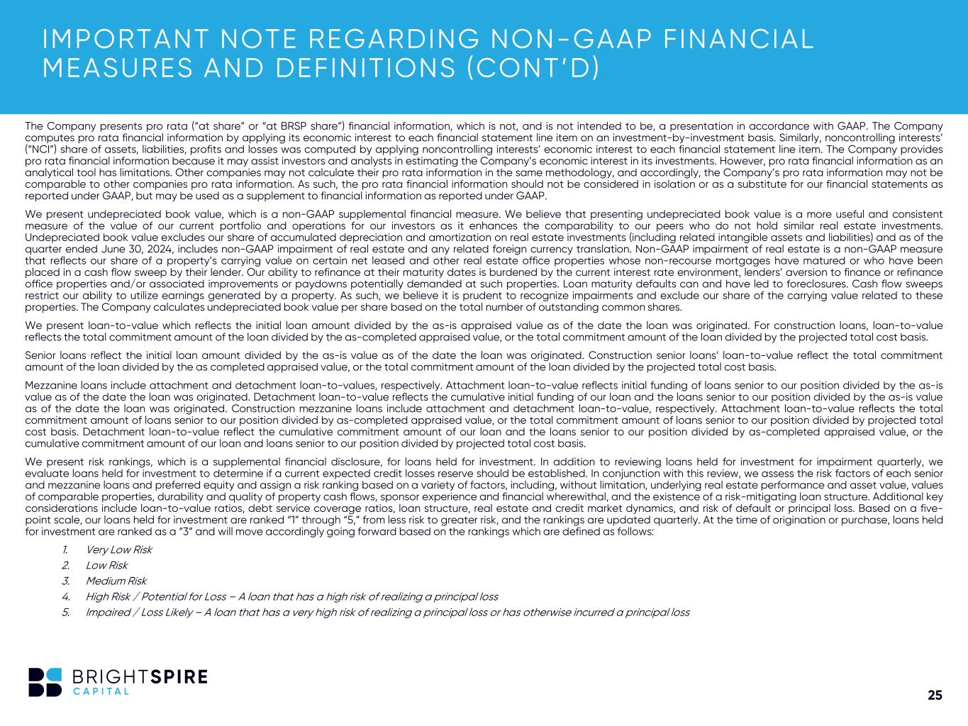
25 The Company presents pro rata (“at share” or “at BRSP share”) financial information, which is not, and is not intended to be, a presentation in accordance with GAAP. The Company computes pro rata financial information by applying its economic interest to each financial statement line item on an investment-by-investment basis. Similarly, noncontrolling interests’ (“NCI”) share of assets, liabilities, profits and losses was computed by applying noncontrolling interests’ economic interest to each financial statement line item. The Company provides pro rata financial information because it may assist investors and analysts in estimating the Company’s economic interest in its investments. However, pro rata financial information as an analytical tool has limitations. Other companies may not calculate their pro rata information in the same methodology, and accordingly, the Company’s pro rata information may not be comparable to other companies pro rata information. As such, the pro rata financial information should not be considered in isolation or as a substitute for our financial statements as reported under GAAP, but may be used as a supplement to financial information as reported under GAAP. We present undepreciated book value, which is a non-GAAP supplemental financial measure. We believe that presenting undepreciated book value is a more useful and consistent measure of the value of our current portfolio and operations for our investors as it enhances the comparability to our peers who do not hold similar real estate investments. Undepreciated book value excludes our share of accumulated depreciation and amortization on real estate investments (including related intangible assets and liabilities) and as of the quarter ended June 30, 2024, includes non-GAAP impairment of real estate and any related foreign currency translation. Non-GAAP impairment of real estate is a non-GAAP measure that reflects our share of a property’s carrying value on certain net leased and other real estate office properties whose non-recourse mortgages have matured or who have been placed in a cash flow sweep by their lender. Our ability to refinance at their maturity dates is burdened by the current interest rate environment, lenders’ aversion to finance or refinance office properties and/or associated improvements or paydowns potentially demanded at such properties. Loan maturity defaults can and have led to foreclosures. Cash flow sweeps restrict our ability to utilize earnings generated by a property. As such, we believe it is prudent to recognize impairments and exclude our share of the carrying value related to these properties. The Company calculates undepreciated book value per share based on the total number of outstanding common shares. We present loan-to-value which reflects the initial loan amount divided by the as-is appraised value as of the date the loan was originated. For construction loans, loan-to-value reflects the total commitment amount of the loan divided by the as-completed appraised value, or the total commitment amount of the loan divided by the projected total cost basis. Senior loans reflect the initial loan amount divided by the as-is value as of the date the loan was originated. Construction senior loans’ loan-to-value reflect the total commitment amount of the loan divided by the as completed appraised value, or the total commitment amount of the loan divided by the projected total cost basis. Mezzanine loans include attachment and detachment loan-to-values, respectively. Attachment loan-to-value reflects initial funding of loans senior to our position divided by the as-is value as of the date the loan was originated. Detachment loan-to-value reflects the cumulative initial funding of our loan and the loans senior to our position divided by the as-is value as of the date the loan was originated. Construction mezzanine loans include attachment and detachment loan-to-value, respectively. Attachment loan-to-value reflects the total commitment amount of loans senior to our position divided by as-completed appraised value, or the total commitment amount of loans senior to our position divided by projected total cost basis. Detachment loan-to-value reflect the cumulative commitment amount of our loan and the loans senior to our position divided by as-completed appraised value, or the cumulative commitment amount of our loan and loans senior to our position divided by projected total cost basis. We present risk rankings, which is a supplemental financial disclosure, for loans held for investment. In addition to reviewing loans held for investment for impairment quarterly, we evaluate loans held for investment to determine if a current expected credit losses reserve should be established. In conjunction with this review, we assess the risk factors of each senior and mezzanine loans and preferred equity and assign a risk ranking based on a variety of factors, including, without limitation, underlying real estate performance and asset value, values of comparable properties, durability and quality of property cash flows, sponsor experience and financial wherewithal, and the existence of a risk-mitigating loan structure. Additional key considerations include loan-to-value ratios, debt service coverage ratios, loan structure, real estate and credit market dynamics, and risk of default or principal loss. Based on a five- point scale, our loans held for investment are ranked “1” through “5,” from less risk to greater risk, and the rankings are updated quarterly. At the time of origination or purchase, loans held for investment are ranked as a “3” and will move accordingly going forward based on the rankings which are defined as follows: 1. Very Low Risk 2. Low Risk 3. Medium Risk 4. High Risk / Potential for Loss – A loan that has a high risk of realizing a principal loss 5. Impaired / Loss Likely – A loan that has a very high risk of realizing a principal loss or has otherwise incurred a principal loss IMPORTANT NOTE REGARDING NON-GAAP FINANCIAL MEASURES AND DEFINITIONS (CONT’D)

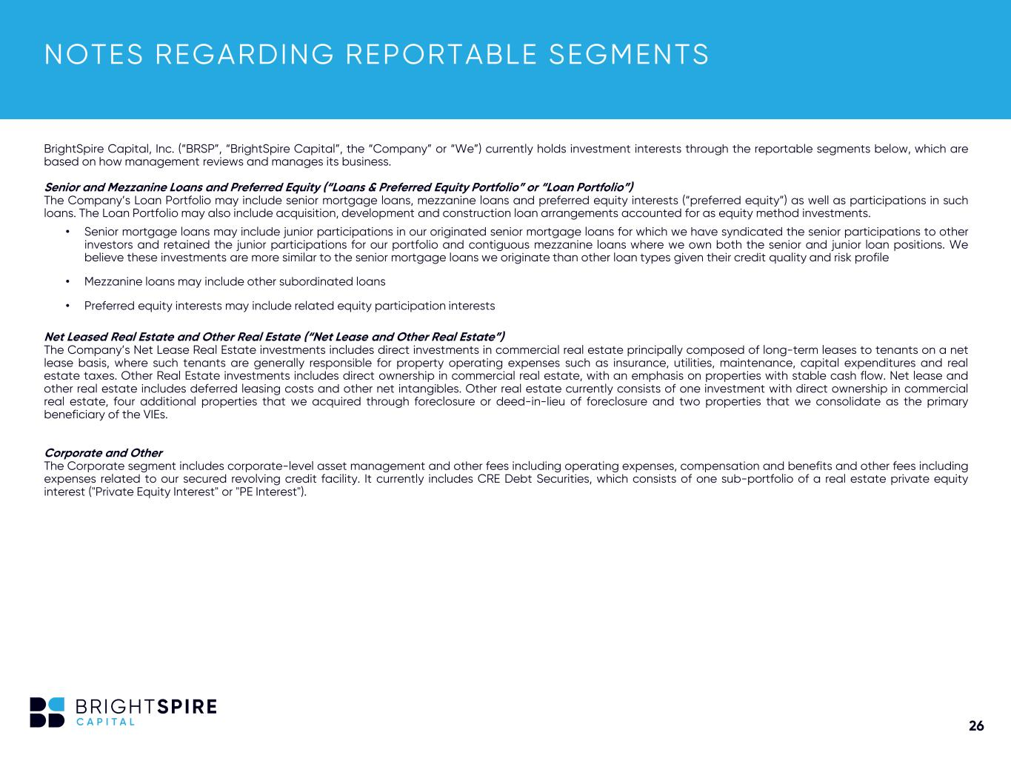
26 NOTES REGARDING REPORTABLE SEGMENTS BrightSpire Capital, Inc. (“BRSP”, “BrightSpire Capital”, the “Company” or “We”) currently holds investment interests through the reportable segments below, which are based on how management reviews and manages its business. Senior and Mezzanine Loans and Preferred Equity (“Loans & Preferred Equity Portfolio” or “Loan Portfolio”) The Company’s Loan Portfolio may include senior mortgage loans, mezzanine loans and preferred equity interests (“preferred equity”) as well as participations in such loans. The Loan Portfolio may also include acquisition, development and construction loan arrangements accounted for as equity method investments. • Senior mortgage loans may include junior participations in our originated senior mortgage loans for which we have syndicated the senior participations to other investors and retained the junior participations for our portfolio and contiguous mezzanine loans where we own both the senior and junior loan positions. We believe these investments are more similar to the senior mortgage loans we originate than other loan types given their credit quality and risk profile • Mezzanine loans may include other subordinated loans • Preferred equity interests may include related equity participation interests Net Leased Real Estate and Other Real Estate (“Net Lease and Other Real Estate”) The Company’s Net Lease Real Estate investments includes direct investments in commercial real estate principally composed of long-term leases to tenants on a net lease basis, where such tenants are generally responsible for property operating expenses such as insurance, utilities, maintenance, capital expenditures and real estate taxes. Other Real Estate investments includes direct ownership in commercial real estate, with an emphasis on properties with stable cash flow. Net lease and other real estate includes deferred leasing costs and other net intangibles. Other real estate currently consists of one investment with direct ownership in commercial real estate, four additional properties that we acquired through foreclosure or deed-in-lieu of foreclosure and two properties that we consolidate as the primary beneficiary of the VIEs. Corporate and Other The Corporate segment includes corporate-level asset management and other fees including operating expenses, compensation and benefits and other fees including expenses related to our secured revolving credit facility. It currently includes CRE Debt Securities, which consists of one sub-portfolio of a real estate private equity interest ("Private Equity Interest" or "PE Interest").

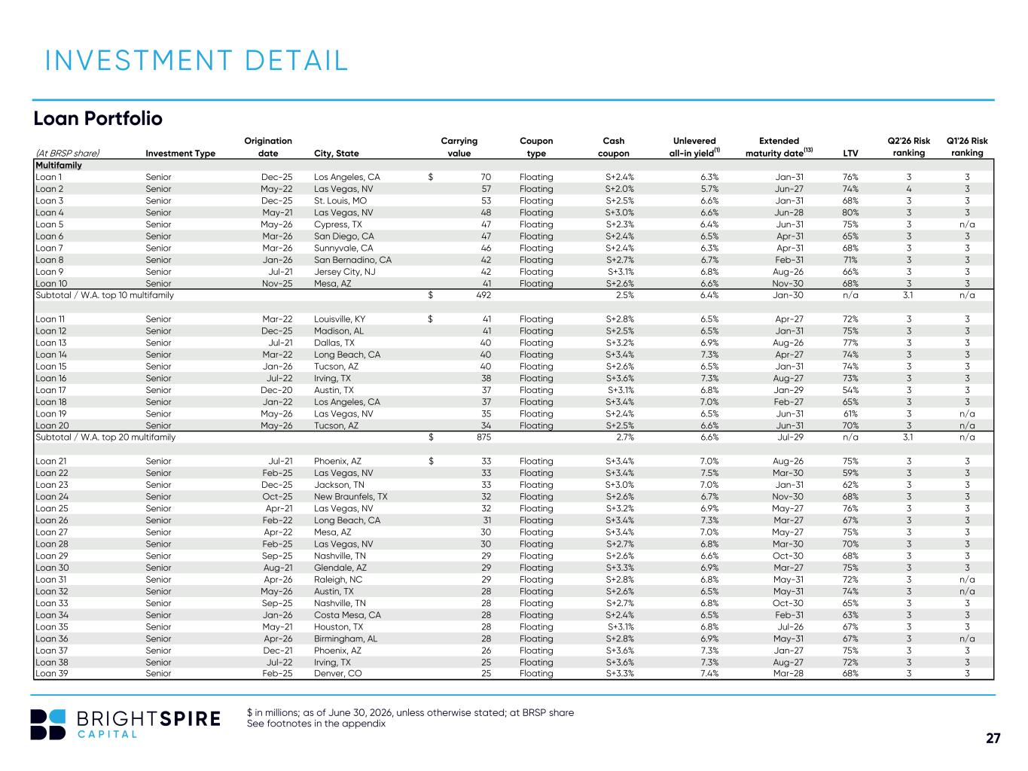
27 INVESTMENT DETAIL $ in millions; as of June 30, 2026, unless otherwise stated; at BRSP share See footnotes in the appendix Loan Portfolio Origination Carrying Coupon Cash Unlevered Extended Q2'26 Risk Q1'26 Risk (At BRSP share) Investment Type date City, State value type coupon all-in yield(1) maturity date(13) LTV ranking ranking Multifamily Loan 1 Senior Dec-25 Los Angeles, CA 70$ Floating S+2.4% 6.3% Jan-31 76% 3 3 Loan 2 Senior May-22 Las Vegas, NV 57 Floating S+2.0% 5.7% Jun-27 74% 4 3 Loan 3 Senior Dec-25 St. Louis, MO 53 Floating S+2.5% 6.6% Jan-31 68% 3 3 Loan 4 Senior May-21 Las Vegas, NV 48 Floating S+3.0% 6.6% Jun-28 80% 3 3 Loan 5 Senior May-26 Cypress, TX 47 Floating S+2.3% 6.4% Jun-31 75% 3 n/a Loan 6 Senior Mar-26 San Diego, CA 47 Floating S+2.4% 6.5% Apr-31 65% 3 3 Loan 7 Senior Mar-26 Sunnyvale, CA 46 Floating S+2.4% 6.3% Apr-31 68% 3 3 Loan 8 Senior Jan-26 San Bernadino, CA 42 Floating S+2.7% 6.7% Feb-31 71% 3 3 Loan 9 Senior Jul-21 Jersey City, NJ 42 Floating S+3.1% 6.8% Aug-26 66% 3 3 Loan 10 Senior Nov-25 Mesa, AZ 41 Floating S+2.6% 6.6% Nov-30 68% 3 3 Subtotal / W.A. top 10 multifamily 492$ 2.5% 6.4% Jan-30 n/a 3.1 n/a Loan 11 Senior Mar-22 Louisville, KY 41$ Floating S+2.8% 6.5% Apr-27 72% 3 3 Loan 12 Senior Dec-25 Madison, AL 41 Floating S+2.5% 6.5% Jan-31 75% 3 3 Loan 13 Senior Jul-21 Dallas, TX 40 Floating S+3.2% 6.9% Aug-26 77% 3 3 Loan 14 Senior Mar-22 Long Beach, CA 40 Floating S+3.4% 7.3% Apr-27 74% 3 3 Loan 15 Senior Jan-26 Tucson, AZ 40 Floating S+2.6% 6.5% Jan-31 74% 3 3 Loan 16 Senior Jul-22 Irving, TX 38 Floating S+3.6% 7.3% Aug-27 73% 3 3 Loan 17 Senior Dec-20 Austin, TX 37 Floating S+3.1% 6.8% Jan-29 54% 3 3 Loan 18 Senior Jan-22 Los Angeles, CA 37 Floating S+3.4% 7.0% Feb-27 65% 3 3 Loan 19 Senior May-26 Las Vegas, NV 35 Floating S+2.4% 6.5% Jun-31 61% 3 n/a Loan 20 Senior May-26 Tucson, AZ 34 Floating S+2.5% 6.6% Jun-31 70% 3 n/a Subtotal / W.A. top 20 multifamily 875$ 2.7% 6.6% Jul-29 n/a 3.1 n/a Loan 21 Senior Jul-21 Phoenix, AZ 33$ Floating S+3.4% 7.0% Aug-26 75% 3 3 Loan 22 Senior Feb-25 Las Vegas, NV 33 Floating S+3.4% 7.5% Mar-30 59% 3 3 Loan 23 Senior Dec-25 Jackson, TN 33 Floating S+3.0% 7.0% Jan-31 62% 3 3 Loan 24 Senior Oct-25 New Braunfels, TX 32 Floating S+2.6% 6.7% Nov-30 68% 3 3 Loan 25 Senior Apr-21 Las Vegas, NV 32 Floating S+3.2% 6.9% May-27 76% 3 3 Loan 26 Senior Feb-22 Long Beach, CA 31 Floating S+3.4% 7.3% Mar-27 67% 3 3 Loan 27 Senior Apr-22 Mesa, AZ 30 Floating S+3.4% 7.0% May-27 75% 3 3 Loan 28 Senior Feb-25 Las Vegas, NV 30 Floating S+2.7% 6.8% Mar-30 70% 3 3 Loan 29 Senior Sep-25 Nashville, TN 29 Floating S+2.6% 6.6% Oct-30 68% 3 3 Loan 30 Senior Aug-21 Glendale, AZ 29 Floating S+3.3% 6.9% Mar-27 75% 3 3 Loan 31 Senior Apr-26 Raleigh, NC 29 Floating S+2.8% 6.8% May-31 72% 3 n/a Loan 32 Senior May-26 Austin, TX 28 Floating S+2.6% 6.5% May-31 74% 3 n/a Loan 33 Senior Sep-25 Nashville, TN 28 Floating S+2.7% 6.8% Oct-30 65% 3 3 Loan 34 Senior Jan-26 Costa Mesa, CA 28 Floating S+2.4% 6.5% Feb-31 63% 3 3 Loan 35 Senior May-21 Houston, TX 28 Floating S+3.1% 6.8% Jul-26 67% 3 3 Loan 36 Senior Apr-26 Birmingham, AL 28 Floating S+2.8% 6.9% May-31 67% 3 n/a Loan 37 Senior Dec-21 Phoenix, AZ 26 Floating S+3.6% 7.3% Jan-27 75% 3 3 Loan 38 Senior Jul-22 Irving, TX 25 Floating S+3.6% 7.3% Aug-27 72% 3 3 Loan 39 Senior Feb-25 Denver, CO 25 Floating S+3.3% 7.4% Mar-28 68% 3 3

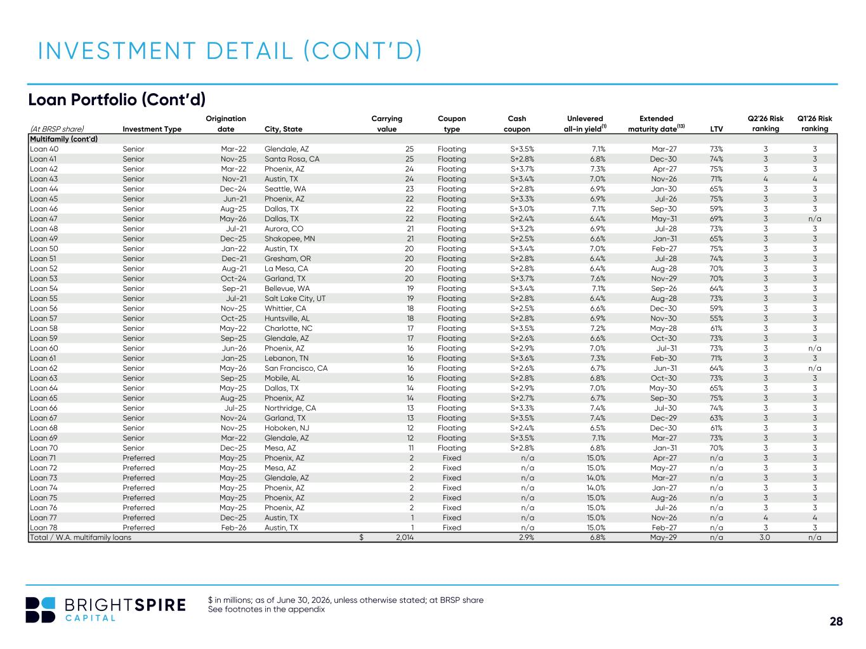
28 Origination Carrying Coupon Cash Unlevered Extended Q2'26 Risk Q1'26 Risk (At BRSP share) Investment Type date City, State value type coupon all-in yield(1) maturity date(13) LTV ranking ranking Multifamily (cont'd) Loan 40 Senior Mar-22 Glendale, AZ 25 Floating S+3.5% 7.1% Mar-27 73% 3 3 Loan 41 Senior Nov-25 Santa Rosa, CA 25 Floating S+2.8% 6.8% Dec-30 74% 3 3 Loan 42 Senior Mar-22 Phoenix, AZ 24 Floating S+3.7% 7.3% Apr-27 75% 3 3 Loan 43 Senior Nov-21 Austin, TX 24 Floating S+3.4% 7.0% Nov-26 71% 4 4 Loan 44 Senior Dec-24 Seattle, WA 23 Floating S+2.8% 6.9% Jan-30 65% 3 3 Loan 45 Senior Jun-21 Phoenix, AZ 22 Floating S+3.3% 6.9% Jul-26 75% 3 3 Loan 46 Senior Aug-25 Dallas, TX 22 Floating S+3.0% 7.1% Sep-30 59% 3 3 Loan 47 Senior May-26 Dallas, TX 22 Floating S+2.4% 6.4% May-31 69% 3 n/a Loan 48 Senior Jul-21 Aurora, CO 21 Floating S+3.2% 6.9% Jul-28 73% 3 3 Loan 49 Senior Dec-25 Shakopee, MN 21 Floating S+2.5% 6.6% Jan-31 65% 3 3 Loan 50 Senior Jan-22 Austin, TX 20 Floating S+3.4% 7.0% Feb-27 75% 3 3 Loan 51 Senior Dec-21 Gresham, OR 20 Floating S+2.8% 6.4% Jul-28 74% 3 3 Loan 52 Senior Aug-21 La Mesa, CA 20 Floating S+2.8% 6.4% Aug-28 70% 3 3 Loan 53 Senior Oct-24 Garland, TX 20 Floating S+3.7% 7.6% Nov-29 70% 3 3 Loan 54 Senior Sep-21 Bellevue, WA 19 Floating S+3.4% 7.1% Sep-26 64% 3 3 Loan 55 Senior Jul-21 Salt Lake City, UT 19 Floating S+2.8% 6.4% Aug-28 73% 3 3 Loan 56 Senior Nov-25 Whittier, CA 18 Floating S+2.5% 6.6% Dec-30 59% 3 3 Loan 57 Senior Oct-25 Huntsville, AL 18 Floating S+2.8% 6.9% Nov-30 55% 3 3 Loan 58 Senior May-22 Charlotte, NC 17 Floating S+3.5% 7.2% May-28 61% 3 3 Loan 59 Senior Sep-25 Glendale, AZ 17 Floating S+2.6% 6.6% Oct-30 73% 3 3 Loan 60 Senior Jun-26 Phoenix, AZ 16 Floating S+2.9% 7.0% Jul-31 73% 3 n/a Loan 61 Senior Jan-25 Lebanon, TN 16 Floating S+3.6% 7.3% Feb-30 71% 3 3 Loan 62 Senior May-26 San Francisco, CA 16 Floating S+2.6% 6.7% Jun-31 64% 3 n/a Loan 63 Senior Sep-25 Mobile, AL 16 Floating S+2.8% 6.8% Oct-30 73% 3 3 Loan 64 Senior May-25 Dallas, TX 14 Floating S+2.9% 7.0% May-30 65% 3 3 Loan 65 Senior Aug-25 Phoenix, AZ 14 Floating S+2.7% 6.7% Sep-30 75% 3 3 Loan 66 Senior Jul-25 Northridge, CA 13 Floating S+3.3% 7.4% Jul-30 74% 3 3 Loan 67 Senior Nov-24 Garland, TX 13 Floating S+3.5% 7.4% Dec-29 63% 3 3 Loan 68 Senior Nov-25 Hoboken, NJ 12 Floating S+2.4% 6.5% Dec-30 61% 3 3 Loan 69 Senior Mar-22 Glendale, AZ 12 Floating S+3.5% 7.1% Mar-27 73% 3 3 Loan 70 Senior Dec-25 Mesa, AZ 11 Floating S+2.8% 6.8% Jan-31 70% 3 3 Loan 71 Preferred May-25 Phoenix, AZ 2 Fixed n/a 15.0% Apr-27 n/a 3 3 Loan 72 Preferred May-25 Mesa, AZ 2 Fixed n/a 15.0% May-27 n/a 3 3 Loan 73 Preferred May-25 Glendale, AZ 2 Fixed n/a 14.0% Mar-27 n/a 3 3 Loan 74 Preferred May-25 Phoenix, AZ 2 Fixed n/a 14.0% Jan-27 n/a 3 3 Loan 75 Preferred May-25 Phoenix, AZ 2 Fixed n/a 15.0% Aug-26 n/a 3 3 Loan 76 Preferred May-25 Phoenix, AZ 2 Fixed n/a 15.0% Jul-26 n/a 3 3 Loan 77 Preferred Dec-25 Austin, TX 1 Fixed n/a 15.0% Nov-26 n/a 4 4 Loan 78 Preferred Feb-26 Austin, TX 1 Fixed n/a 15.0% Feb-27 n/a 3 3 Total / W.A. multifamily loans 2,014$ 2.9% 6.8% May-29 n/a 3.0 n/a Loan Portfolio (Cont’d) INVESTMENT DETAIL (CONT’D) $ in millions; as of June 30, 2026, unless otherwise stated; at BRSP share See footnotes in the appendix

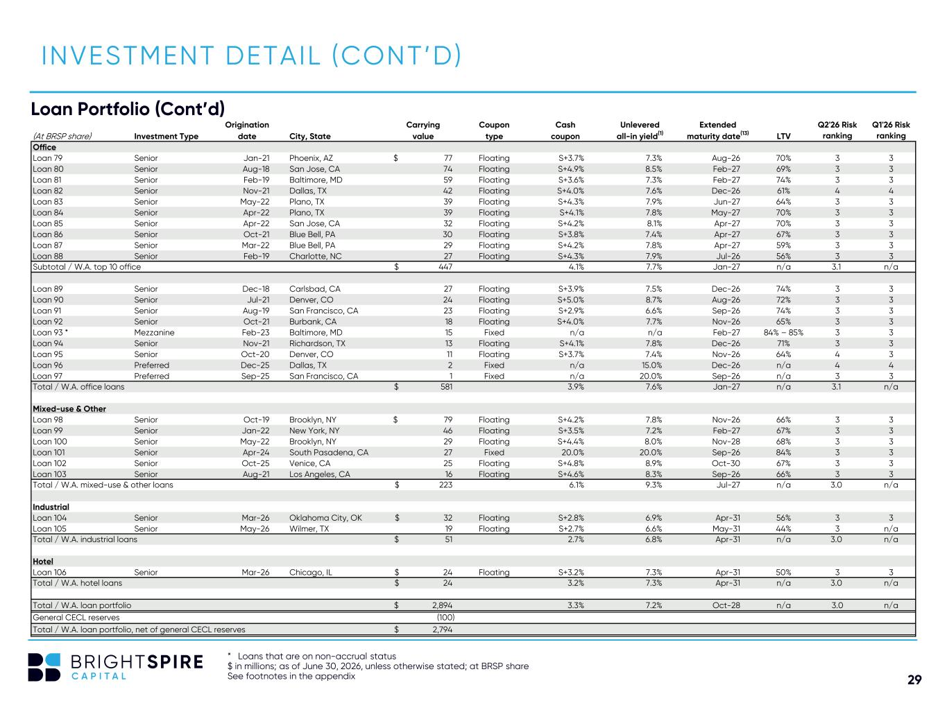
29 Origination Carrying Coupon Cash Unlevered Extended Q2'26 Risk Q1'26 Risk (At BRSP share) Investment Type date City, State value type coupon all-in yield(1) maturity date(13) LTV ranking ranking Office Loan 79 Senior Jan-21 Phoenix, AZ 77$ Floating S+3.7% 7.3% Aug-26 70% 3 3 Loan 80 Senior Aug-18 San Jose, CA 74 Floating S+4.9% 8.5% Feb-27 69% 3 3 Loan 81 Senior Feb-19 Baltimore, MD 59 Floating S+3.6% 7.3% Feb-27 74% 3 3 Loan 82 Senior Nov-21 Dallas, TX 42 Floating S+4.0% 7.6% Dec-26 61% 4 4 Loan 83 Senior May-22 Plano, TX 39 Floating S+4.3% 7.9% Jun-27 64% 3 3 Loan 84 Senior Apr-22 Plano, TX 39 Floating S+4.1% 7.8% May-27 70% 3 3 Loan 85 Senior Apr-22 San Jose, CA 32 Floating S+4.2% 8.1% Apr-27 70% 3 3 Loan 86 Senior Oct-21 Blue Bell, PA 30 Floating S+3.8% 7.4% Apr-27 67% 3 3 Loan 87 Senior Mar-22 Blue Bell, PA 29 Floating S+4.2% 7.8% Apr-27 59% 3 3 Loan 88 Senior Feb-19 Charlotte, NC 27 Floating S+4.3% 7.9% Jul-26 56% 3 3 Subtotal / W.A. top 10 office 447$ 4.1% 7.7% Jan-27 n/a 3.1 n/a Loan 89 Senior Dec-18 Carlsbad, CA 27 Floating S+3.9% 7.5% Dec-26 74% 3 3 Loan 90 Senior Jul-21 Denver, CO 24 Floating S+5.0% 8.7% Aug-26 72% 3 3 Loan 91 Senior Aug-19 San Francisco, CA 23 Floating S+2.9% 6.6% Sep-26 74% 3 3 Loan 92 Senior Oct-21 Burbank, CA 18 Floating S+4.0% 7.7% Nov-26 65% 3 3 Loan 93 * Mezzanine Feb-23 Baltimore, MD 15 Fixed n/a n/a Feb-27 84% – 85% 3 3 Loan 94 Senior Nov-21 Richardson, TX 13 Floating S+4.1% 7.8% Dec-26 71% 3 3 Loan 95 Senior Oct-20 Denver, CO 11 Floating S+3.7% 7.4% Nov-26 64% 4 3 Loan 96 Preferred Dec-25 Dallas, TX 2 Fixed n/a 15.0% Dec-26 n/a 4 4 Loan 97 Preferred Sep-25 San Francisco, CA 1 Fixed n/a 20.0% Sep-26 n/a 3 3 Total / W.A. office loans 581$ 3.9% 7.6% Jan-27 n/a 3.1 n/a Mixed-use & Other Loan 98 Senior Oct-19 Brooklyn, NY 79$ Floating S+4.2% 7.8% Nov-26 66% 3 3 Loan 99 Senior Jan-22 New York, NY 46 Floating S+3.5% 7.2% Feb-27 67% 3 3 Loan 100 Senior May-22 Brooklyn, NY 29 Floating S+4.4% 8.0% Nov-28 68% 3 3 Loan 101 Senior Apr-24 South Pasadena, CA 27 Fixed 20.0% 20.0% Sep-26 84% 3 3 Loan 102 Senior Oct-25 Venice, CA 25 Floating S+4.8% 8.9% Oct-30 67% 3 3 Loan 103 Senior Aug-21 Los Angeles, CA 16 Floating S+4.6% 8.3% Sep-26 66% 3 3 Total / W.A. mixed-use & other loans 223$ 6.1% 9.3% Jul-27 n/a 3.0 n/a Industrial Loan 104 Senior Mar-26 Oklahoma City, OK 32$ Floating S+2.8% 6.9% Apr-31 56% 3 3 Loan 105 Senior May-26 Wilmer, TX 19 Floating S+2.7% 6.6% May-31 44% 3 n/a Total / W.A. industrial loans 51$ 2.7% 6.8% Apr-31 n/a 3.0 n/a Hotel Loan 106 Senior Mar-26 Chicago, IL 24$ Floating S+3.2% 7.3% Apr-31 50% 3 3 Total / W.A. hotel loans 24$ 3.2% 7.3% Apr-31 n/a 3.0 n/a Total / W.A. loan portfolio 2,894$ 3.3% 7.2% Oct-28 n/a 3.0 n/a General CECL reserves (100) Total / W.A. loan portfolio, net of general CECL reserves 2,794$ INVESTMENT DETAIL (CONT’D) * Loans that are on non-accrual status $ in millions; as of June 30, 2026, unless otherwise stated; at BRSP share See footnotes in the appendix Loan Portfolio (Cont’d)

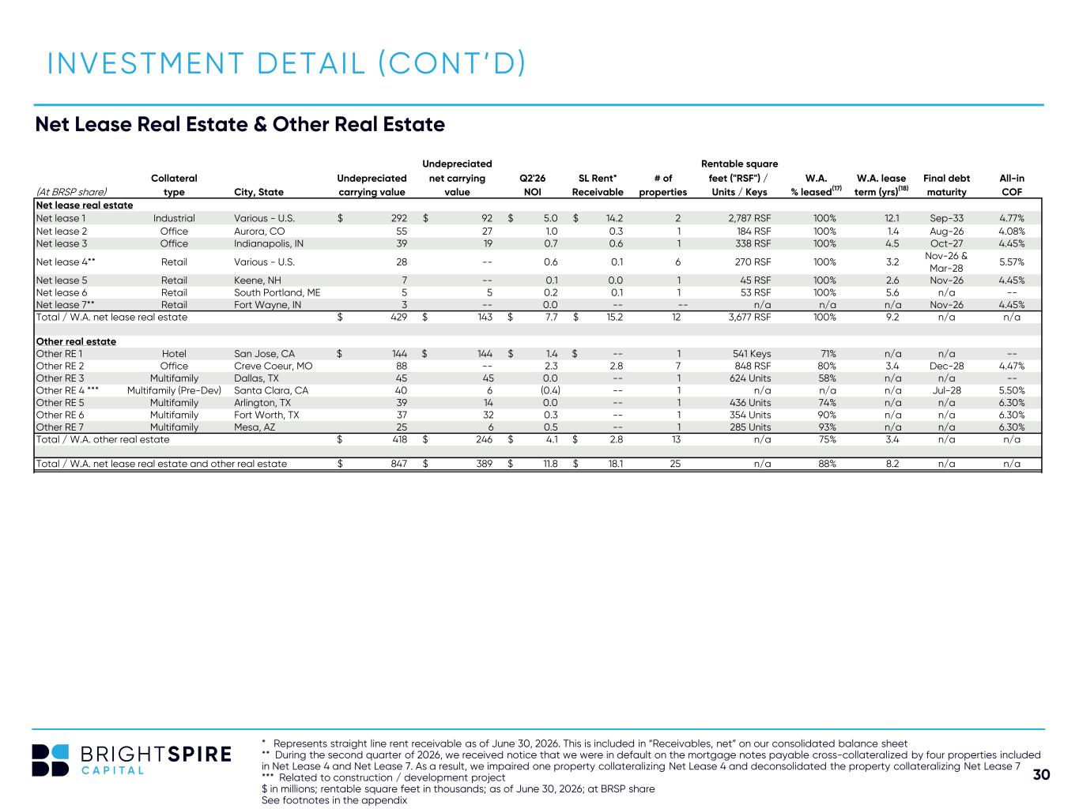
30 Undepreciated Rentable square Collateral Undepreciated net carrying Q2'26 SL Rent* # of feet ("RSF") / W.A. W.A. lease Final debt All-in (At BRSP share) type City, State carrying value value NOI Receivable properties Units / Keys % leased(17) term (yrs)(18) maturity COF Net lease real estate Net lease 1 Industrial Various - U.S. 292$ 92$ 5.0$ 14.2$ 2 2,787 RSF 100% 12.1 Sep-33 4.77% Net lease 2 Office Aurora, CO 55 27 1.0 0.3 1 184 RSF 100% 1.4 Aug-26 4.08% Net lease 3 Office Indianapolis, IN 39 19 0.7 0.6 1 338 RSF 100% 4.5 Oct-27 4.45% Net lease 4** Retail Various - U.S. 28 -- 0.6 0.1 6 270 RSF 100% 3.2 Nov-26 & Mar-28 5.57% Net lease 5 Retail Keene, NH 7 -- 0.1 0.0 1 45 RSF 100% 2.6 Nov-26 4.45% Net lease 6 Retail South Portland, ME 5 5 0.2 0.1 1 53 RSF 100% 5.6 n/a -- Net lease 7** Retail Fort Wayne, IN 3 -- 0.0 -- -- n/a n/a n/a Nov-26 4.45% Total / W.A. net lease real estate 429$ 143$ 7.7$ 15.2$ 12 3,677 RSF 100% 9.2 n/a n/a Other real estate Other RE 1 Hotel San Jose, CA 144$ 144$ 1.4$ $ -- 1 541 Keys 71% n/a n/a -- Other RE 2 Office Creve Coeur, MO 88 -- 2.3 2.8 7 848 RSF 80% 3.4 Dec-28 4.47% Other RE 3 Multifamily Dallas, TX 45 45 0.0 -- 1 624 Units 58% n/a n/a -- Other RE 4 *** Multifamily (Pre-Dev) Santa Clara, CA 40 6 (0.4) -- 1 n/a n/a n/a Jul-28 5.50% Other RE 5 Multifamily Arlington, TX 39 14 0.0 -- 1 436 Units 74% n/a n/a 6.30% Other RE 6 Multifamily Fort Worth, TX 37 32 0.3 -- 1 354 Units 90% n/a n/a 6.30% Other RE 7 Multifamily Mesa, AZ 25 6 0.5 -- 1 285 Units 93% n/a n/a 6.30% Total / W.A. other real estate 418$ 246$ 4.1$ 2.8$ 13 n/a 75% 3.4 n/a n/a Total / W.A. net lease real estate and other real estate 847$ 389$ 11.8$ 18.1$ 25 n/a 88% 8.2 n/a n/a INVESTMENT DETAIL (CONT’D) * Represents straight line rent receivable as of June 30, 2026. This is included in “Receivables, net” on our consolidated balance sheet ** During the second quarter of 2026, we received notice that we were in default on the mortgage notes payable cross-collateralized by four properties included in Net Lease 4 and Net Lease 7. As a result, we impaired one property collateralizing Net Lease 4 and deconsolidated the property collateralizing Net Lease 7 *** Related to construction / development project $ in millions; rentable square feet in thousands; as of June 30, 2026; at BRSP share See footnotes in the appendix Net Lease Real Estate & Other Real Estate

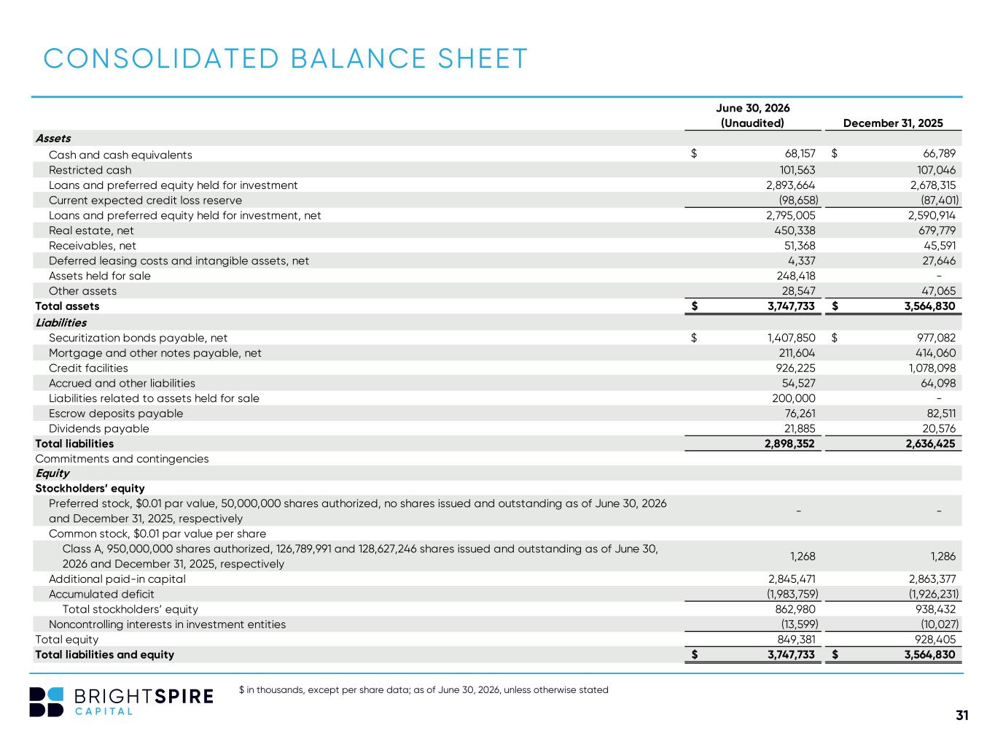
31 $ in thousands, except per share data; as of June 30, 2026, unless otherwise stated CONSOLIDATED BALANCE SHEET June 30, 2026 (Unaudited) December 31, 2025 Assets Cash and cash equivalents 68,157$ 66,789$ Restricted cash 101,563 107,046 Loans and preferred equity held for investment 2,893,664 2,678,315 Current expected credit loss reserve (98,658) (87,401) Loans and preferred equity held for investment, net 2,795,005 2,590,914 Real estate, net 450,338 679,779 Receivables, net 51,368 45,591 Deferred leasing costs and intangible assets, net 4,337 27,646 Assets held for sale 248,418 - Other assets 28,547 47,065 Total assets 3,747,733$ 3,564,830$ Liabilities Securitization bonds payable, net 1,407,850$ 977,082$ Mortgage and other notes payable, net 211,604 414,060 Credit facilities 926,225 1,078,098 Accrued and other liabilities 54,527 64,098 Liabilities related to assets held for sale 200,000 - Escrow deposits payable 76,261 82,511 Dividends payable 21,885 20,576 Total liabilities 2,898,352 2,636,425 Commitments and contingencies Equity Stockholders’ equity Preferred stock, $0.01 par value, 50,000,000 shares authorized, no shares issued and outstanding as of June 30, 2026 and December 31, 2025, respectively - - Common stock, $0.01 par value per share Class A, 950,000,000 shares authorized, 126,789,991 and 128,627,246 shares issued and outstanding as of June 30, 2026 and December 31, 2025, respectively 1,268 1,286 Additional paid-in capital 2,845,471 2,863,377 Accumulated deficit (1,983,759) (1,926,231) Total stockholders’ equity 862,980 938,432 Noncontrolling interests in investment entities (13,599) (10,027) Total equity 849,381 928,405 Total liabilities and equity 3,747,733$ 3,564,830$

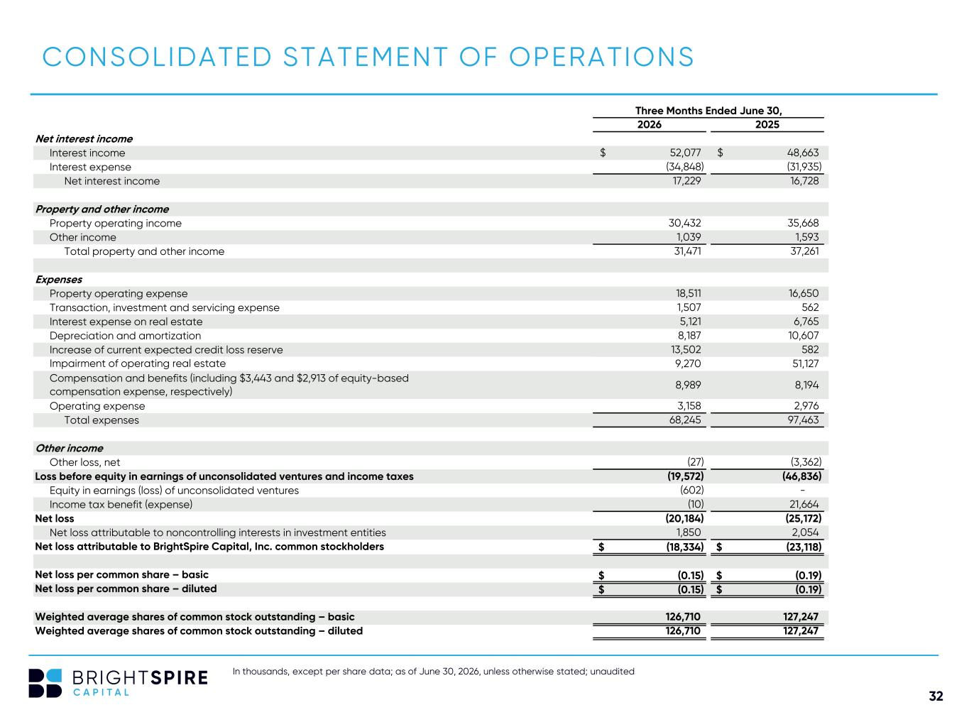
32 In thousands, except per share data; as of June 30, 2026, unless otherwise stated; unaudited CONSOLIDATED STATEMENT OF OPERATIONS Three Months Ended June 30, 2026 2025 Net interest income Interest income 52,077$ 48,663$ Interest expense (34,848) (31,935) Net interest income 17,229 16,728 Property and other income Property operating income 30,432 35,668 Other income 1,039 1,593 Total property and other income 31,471 37,261 Expenses Property operating expense 18,511 16,650 Transaction, investment and servicing expense 1,507 562 Interest expense on real estate 5,121 6,765 Depreciation and amortization 8,187 10,607 Increase of current expected credit loss reserve 13,502 582 Impairment of operating real estate 9,270 51,127 Compensation and benefits (including $3,443 and $2,913 of equity-based compensation expense, respectively) 8,989 8,194 Operating expense 3,158 2,976 Total expenses 68,245 97,463 Other income Other loss, net (27) (3,362) Loss before equity in earnings of unconsolidated ventures and income taxes (19,572) (46,836) Equity in earnings (loss) of unconsolidated ventures (602) - Income tax benefit (expense) (10) 21,664 Net loss (20,184) (25,172) Net loss attributable to noncontrolling interests in investment entities 1,850 2,054 Net loss attributable to BrightSpire Capital, Inc. common stockholders (18,334)$ (23,118)$ Net loss per common share – basic (0.15)$ (0.19)$ Net loss per common share – diluted (0.15)$ (0.19)$ Weighted average shares of common stock outstanding – basic 126,710 127,247 Weighted average shares of common stock outstanding – diluted 126,710 127,247

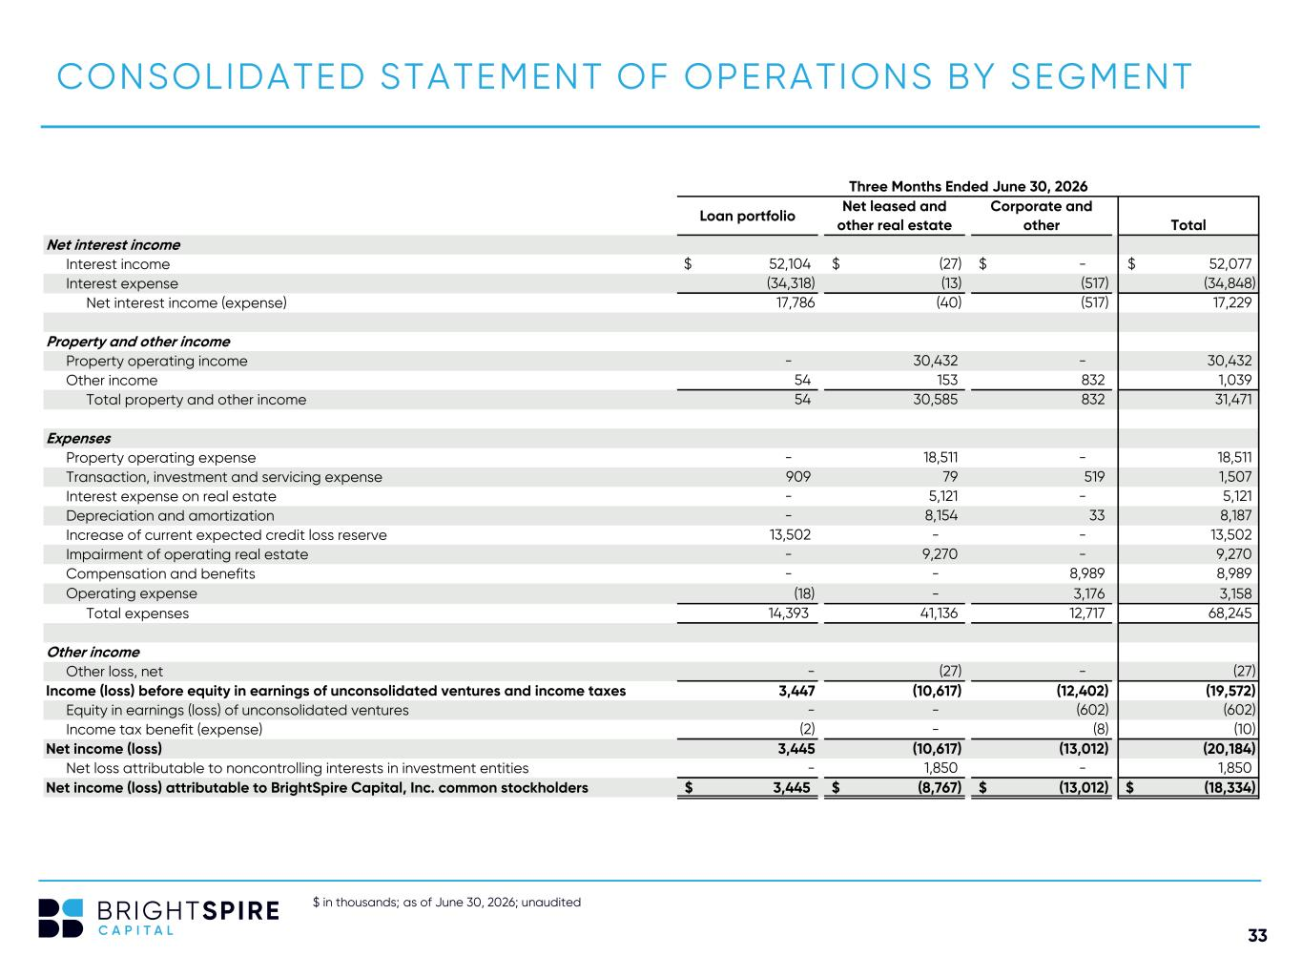
33 $ in thousands; as of June 30, 2026; unaudited CONSOLIDATED STATEMENT OF OPERATIONS BY SEGMENT Three Months Ended June 30, 2026 Loan portfolio Net leased and other real estate Corporate and other Total Net interest income Interest income 52,104$ (27)$ -$ 52,077$ Interest expense (34,318) (13) (517) (34,848) Net interest income (expense) 17,786 (40) (517) 17,229 Property and other income Property operating income - 30,432 - 30,432 Other income 54 153 832 1,039 Total property and other income 54 30,585 832 31,471 Expenses Property operating expense - 18,511 - 18,511 Transaction, investment and servicing expense 909 79 519 1,507 Interest expense on real estate - 5,121 - 5,121 Depreciation and amortization - 8,154 33 8,187 Increase of current expected credit loss reserve 13,502 - - 13,502 Impairment of operating real estate - 9,270 - 9,270 Compensation and benefits - - 8,989 8,989 Operating expense (18) - 3,176 3,158 Total expenses 14,393 41,136 12,717 68,245 Other income Other loss, net - (27) - (27) Income (loss) before equity in earnings of unconsolidated ventures and income taxes 3,447 (10,617) (12,402) (19,572) Equity in earnings (loss) of unconsolidated ventures - - (602) (602) Income tax benefit (expense) (2) - (8) (10) Net income (loss) 3,445 (10,617) (13,012) (20,184) Net loss attributable to noncontrolling interests in investment entities - 1,850 - 1,850 Net income (loss) attributable to BrightSpire Capital, Inc. common stockholders 3,445$ (8,767)$ (13,012)$ (18,334)$

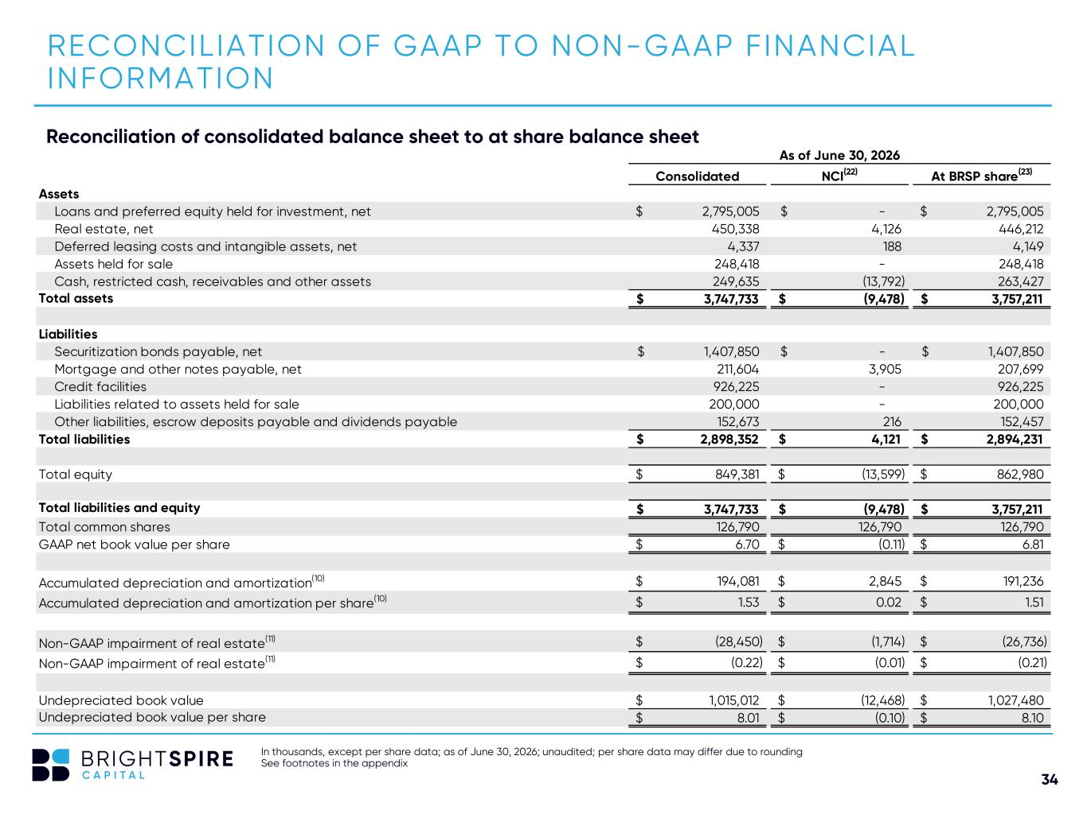
34 Reconciliation of consolidated balance sheet to at share balance sheet In thousands, except per share data; as of June 30, 2026; unaudited; per share data may differ due to rounding See footnotes in the appendix RECONCILIATION OF GAAP TO NON-GAAP FINANCIAL INFORMATION As of June 30, 2026 Consolidated NCI(22) At BRSP share(23) Assets Loans and preferred equity held for investment, net 2,795,005$ -$ 2,795,005$ Real estate, net 450,338 4,126 446,212 Deferred leasing costs and intangible assets, net 4,337 188 4,149 Assets held for sale 248,418 - 248,418 Cash, restricted cash, receivables and other assets 249,635 (13,792) 263,427 Total assets 3,747,733$ (9,478)$ 3,757,211$ Liabilities Securitization bonds payable, net 1,407,850$ -$ 1,407,850$ Mortgage and other notes payable, net 211,604 3,905 207,699 Credit facilities 926,225 - 926,225 Liabilities related to assets held for sale 200,000 - 200,000 Other liabilities, escrow deposits payable and dividends payable 152,673 216 152,457 Total liabilities 2,898,352$ 4,121$ 2,894,231$ Total equity 849,381$ (13,599)$ 862,980$ Total liabilities and equity 3,747,733$ (9,478)$ 3,757,211$ Total common shares 126,790 126,790 126,790 GAAP net book value per share 6.70$ (0.11)$ 6.81$ Accumulated depreciation and amortization(10) 194,081$ 2,845$ 191,236$ Accumulated depreciation and amortization per share(10) 1.53$ 0.02$ 1.51$ Non-GAAP impairment of real estate(11) (28,450)$ (1,714)$ (26,736)$ Non-GAAP impairment of real estate(11) (0.22)$ (0.01)$ (0.21)$ Undepreciated book value 1,015,012$ (12,468)$ 1,027,480$ Undepreciated book value per share 8.01$ (0.10)$ 8.10$

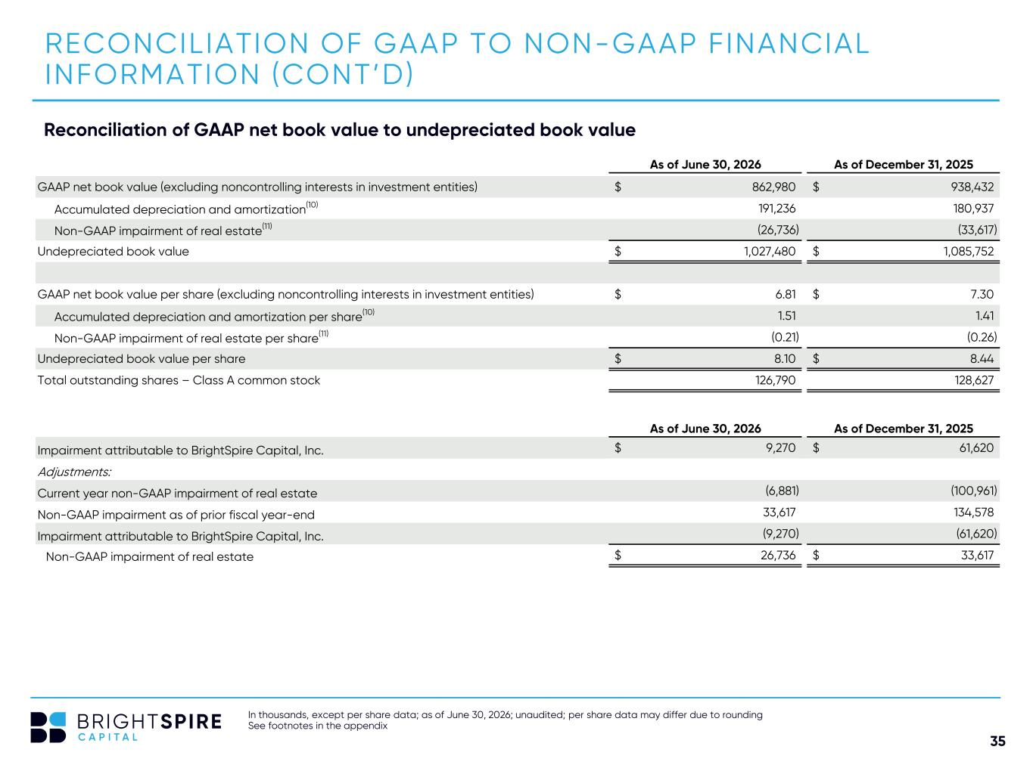
35 RECONCILIATION OF GAAP TO NON-GAAP FINANCIAL INFORMATION (CONT’D) Reconciliation of GAAP net book value to undepreciated book value In thousands, except per share data; as of June 30, 2026; unaudited; per share data may differ due to rounding See footnotes in the appendix As of June 30, 2026 As of December 31, 2025 GAAP net book value (excluding noncontrolling interests in investment entities) 862,980$ 938,432$ Accumulated depreciation and amortization(10) 191,236 180,937 Non-GAAP impairment of real estate(11) (26,736) (33,617) Undepreciated book value 1,027,480$ 1,085,752$ GAAP net book value per share (excluding noncontrolling interests in investment entities) 6.81$ 7.30$ Accumulated depreciation and amortization per share(10) 1.51 1.41 Non-GAAP impairment of real estate per share(11) (0.21) (0.26) Undepreciated book value per share 8.10$ 8.44$ Total outstanding shares – Class A common stock 126,790 128,627 As of June 30, 2026 As of December 31, 2025 Impairment attributable to BrightSpire Capital, Inc. 9,270$ 61,620$ Adjustments: Current year non-GAAP impairment of real estate (6,881) (100,961) Non-GAAP impairment as of prior fiscal year-end 33,617 134,578 Impairment attributable to BrightSpire Capital, Inc. (9,270) (61,620) Non-GAAP impairment of real estate 26,736$ 33,617$

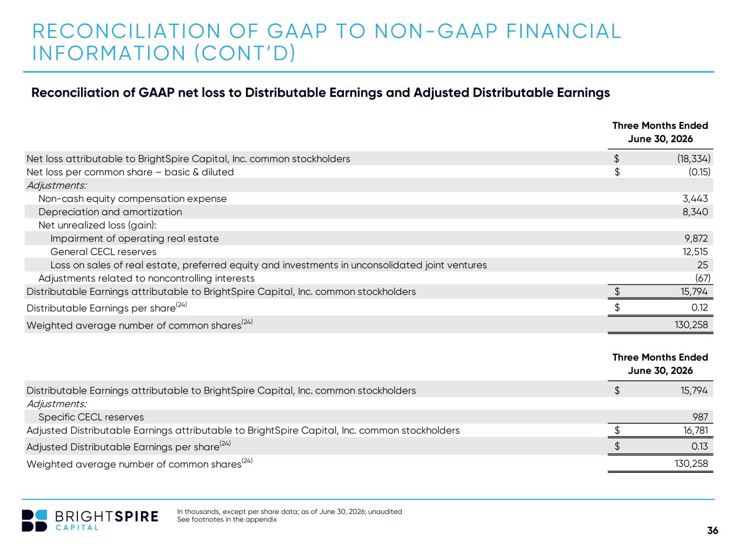
36 Reconciliation of GAAP net loss to Distributable Earnings and Adjusted Distributable Earnings In thousands, except per share data; as of June 30, 2026; unaudited See footnotes in the appendix RECONCILIATION OF GAAP TO NON-GAAP FINANCIAL INFORMATION (CONT’D) Three Months Ended June 30, 2026 Net loss attributable to BrightSpire Capital, Inc. common stockholders (18,334)$ Net loss per common share – basic & diluted (0.15)$ Adjustments: Non-cash equity compensation expense 3,443 Depreciation and amortization 8,340 Net unrealized loss (gain): Impairment of operating real estate 9,872 General CECL reserves 12,515 Loss on sales of real estate, preferred equity and investments in unconsolidated joint ventures 25 Adjustments related to noncontrolling interests (67) Distributable Earnings attributable to BrightSpire Capital, Inc. common stockholders 15,794$ Distributable Earnings per share(24) 0.12$ Weighted average number of common shares(24) 130,258 Three Months Ended June 30, 2026 Distributable Earnings attributable to BrightSpire Capital, Inc. common stockholders 15,794$ Adjustments: Specific CECL reserves 987 Adjusted Distributable Earnings attributable to BrightSpire Capital, Inc. common stockholders 16,781$ Adjusted Distributable Earnings per share(24) 0.13$ Weighted average number of common shares(24) 130,258

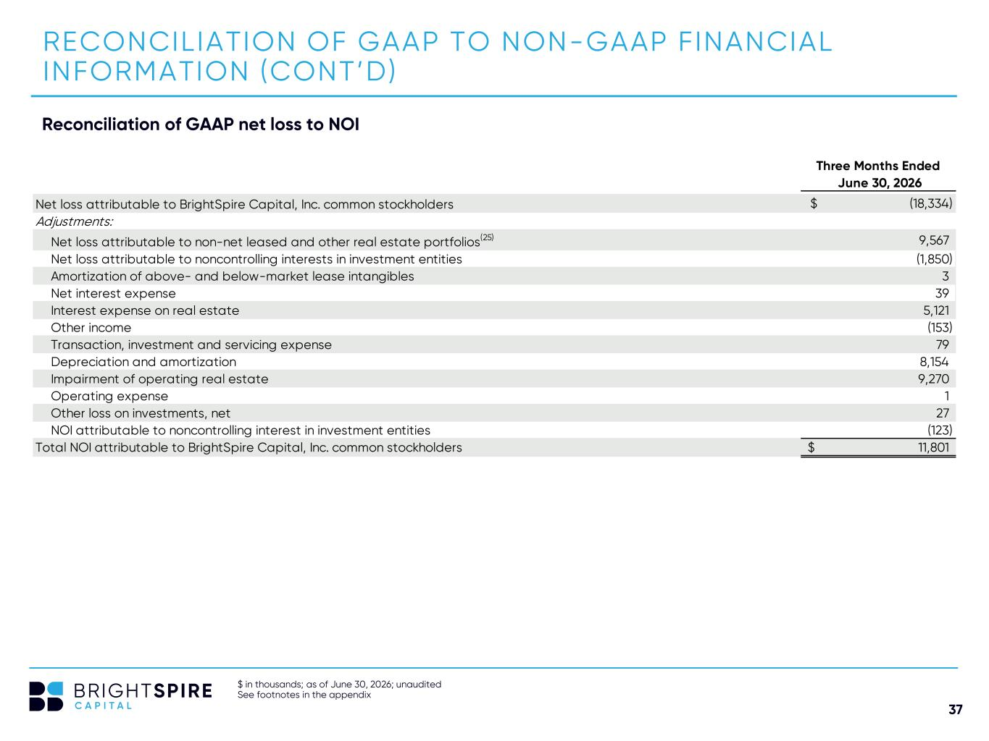
37 Reconciliation of GAAP net loss to NOI $ in thousands; as of June 30, 2026; unaudited See footnotes in the appendix RECONCILIATION OF GAAP TO NON-GAAP FINANCIAL INFORMATION (CONT’D) Three Months Ended June 30, 2026 Net loss attributable to BrightSpire Capital, Inc. common stockholders (18,334)$ Adjustments: Net loss attributable to non-net leased and other real estate portfolios(25) 9,567 Net loss attributable to noncontrolling interests in investment entities (1,850) Amortization of above- and below-market lease intangibles 3 Net interest expense 39 Interest expense on real estate 5,121 Other income (153) Transaction, investment and servicing expense 79 Depreciation and amortization 8,154 Impairment of operating real estate 9,270 Operating expense 1 Other loss on investments, net 27 NOI attributable to noncontrolling interest in investment entities (123) Total NOI attributable to BrightSpire Capital, Inc. common stockholders 11,801$

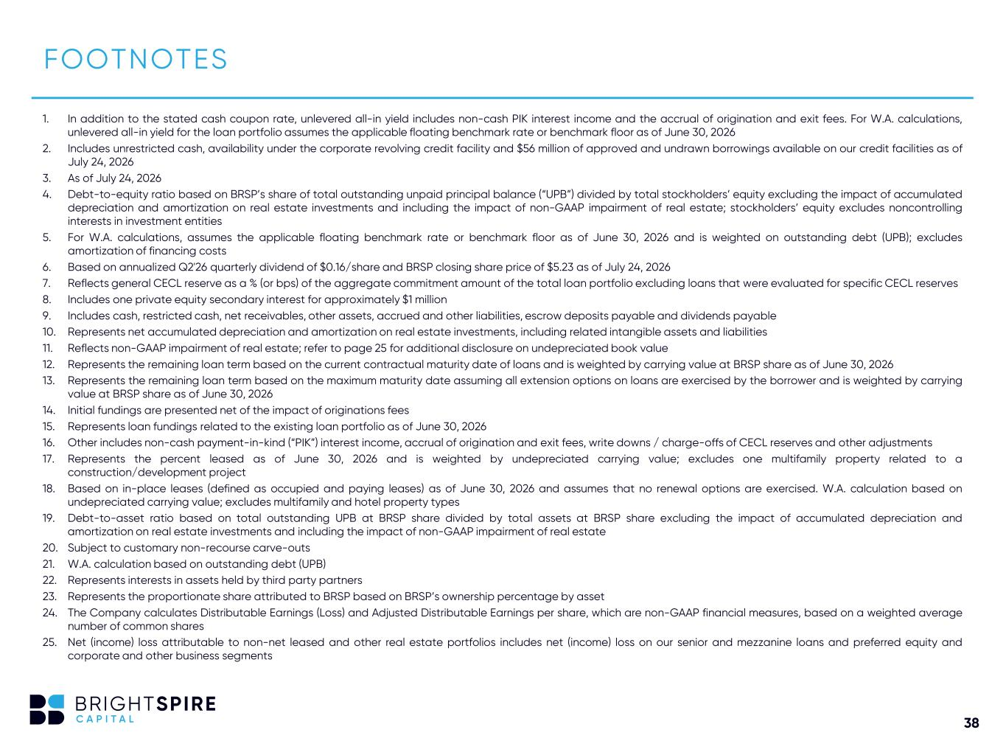
38 1. In addition to the stated cash coupon rate, unlevered all-in yield includes non-cash PIK interest income and the accrual of origination and exit fees. For W.A. calculations, unlevered all-in yield for the loan portfolio assumes the applicable floating benchmark rate or benchmark floor as of June 30, 2026 2. Includes unrestricted cash, availability under the corporate revolving credit facility and $56 million of approved and undrawn borrowings available on our credit facilities as of July 24, 2026 3. As of July 24, 2026 4. Debt-to-equity ratio based on BRSP’s share of total outstanding unpaid principal balance (“UPB”) divided by total stockholders’ equity excluding the impact of accumulated depreciation and amortization on real estate investments and including the impact of non-GAAP impairment of real estate; stockholders’ equity excludes noncontrolling interests in investment entities 5. For W.A. calculations, assumes the applicable floating benchmark rate or benchmark floor as of June 30, 2026 and is weighted on outstanding debt (UPB); excludes amortization of financing costs 6. Based on annualized Q2'26 quarterly dividend of $0.16/share and BRSP closing share price of $5.23 as of July 24, 2026 7. Reflects general CECL reserve as a % (or bps) of the aggregate commitment amount of the total loan portfolio excluding loans that were evaluated for specific CECL reserves 8. Includes one private equity secondary interest for approximately $1 million 9. Includes cash, restricted cash, net receivables, other assets, accrued and other liabilities, escrow deposits payable and dividends payable 10. Represents net accumulated depreciation and amortization on real estate investments, including related intangible assets and liabilities 11. Reflects non-GAAP impairment of real estate; refer to page 25 for additional disclosure on undepreciated book value 12. Represents the remaining loan term based on the current contractual maturity date of loans and is weighted by carrying value at BRSP share as of June 30, 2026 13. Represents the remaining loan term based on the maximum maturity date assuming all extension options on loans are exercised by the borrower and is weighted by carrying value at BRSP share as of June 30, 2026 14. Initial fundings are presented net of the impact of originations fees 15. Represents loan fundings related to the existing loan portfolio as of June 30, 2026 16. Other includes non-cash payment-in-kind (“PIK”) interest income, accrual of origination and exit fees, write downs / charge-offs of CECL reserves and other adjustments 17. Represents the percent leased as of June 30, 2026 and is weighted by undepreciated carrying value; excludes one multifamily property related to a construction/development project 18. Based on in-place leases (defined as occupied and paying leases) as of June 30, 2026 and assumes that no renewal options are exercised. W.A. calculation based on undepreciated carrying value; excludes multifamily and hotel property types 19. Debt-to-asset ratio based on total outstanding UPB at BRSP share divided by total assets at BRSP share excluding the impact of accumulated depreciation and amortization on real estate investments and including the impact of non-GAAP impairment of real estate 20. Subject to customary non-recourse carve-outs 21. W.A. calculation based on outstanding debt (UPB) 22. Represents interests in assets held by third party partners 23. Represents the proportionate share attributed to BRSP based on BRSP’s ownership percentage by asset 24. The Company calculates Distributable Earnings (Loss) and Adjusted Distributable Earnings per share, which are non-GAAP financial measures, based on a weighted average number of common shares 25. Net (income) loss attributable to non-net leased and other real estate portfolios includes net (income) loss on our senior and mezzanine loans and preferred equity and corporate and other business segments FOOTNOTES

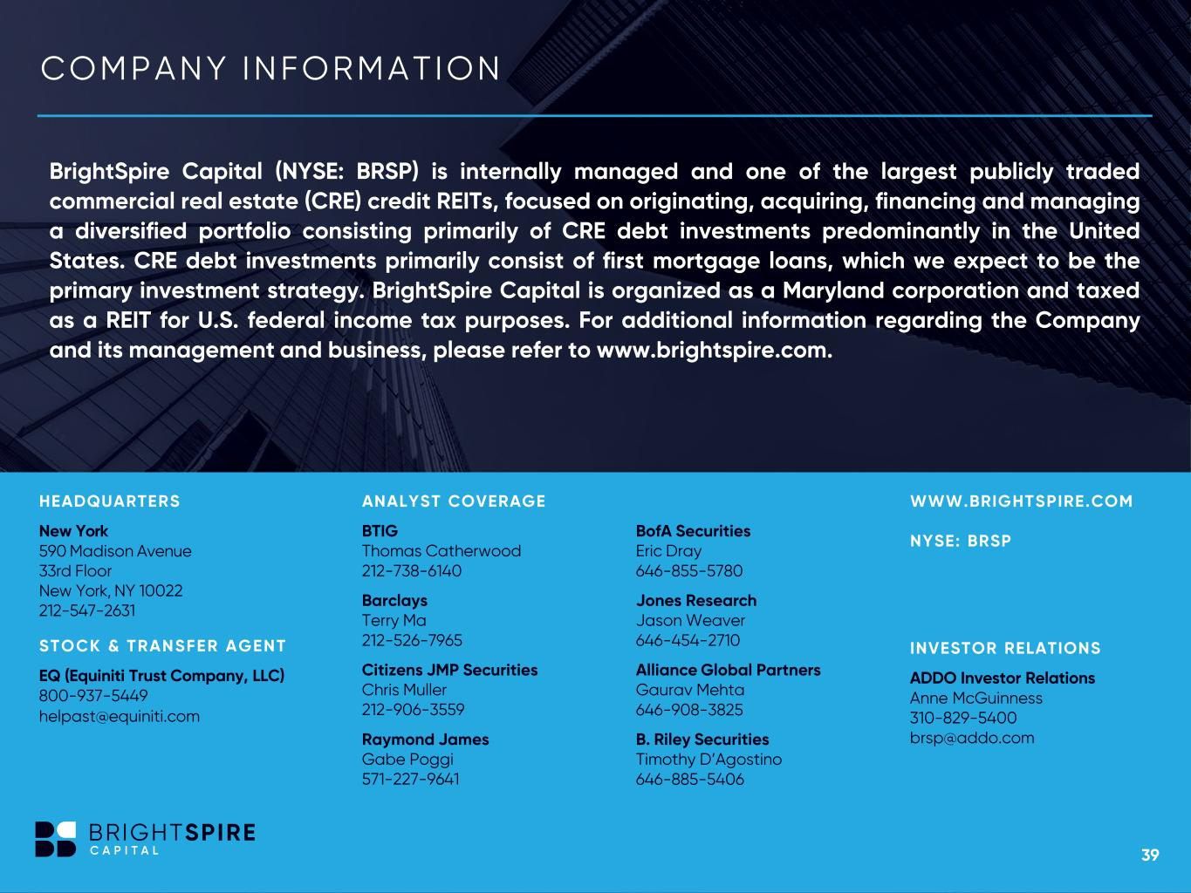
39 COM P AN Y IN F OR M ATION 39 BrightSpire Capital (NYSE: BRSP) is internally managed and one of the largest publicly traded commercial real estate (CRE) credit REITs, focused on originating, acquiring, financing and managing a diversified portfolio consisting primarily of CRE debt investments predominantly in the United States. CRE debt investments primarily consist of first mortgage loans, which we expect to be the primary investment strategy. BrightSpire Capital is organized as a Maryland corporation and taxed as a REIT for U.S. federal income tax purposes. For additional information regarding the Company and its management and business, please refer to www.brightspire.com. HEADQUARTERS New York 590 Madison Avenue 33rd Floor New York, NY 10022 212-547-2631 STOCK & TRANSFER AGENT EQ (Equiniti Trust Company, LLC) 800-937-5449 helpast@equiniti.com INVESTOR RELATIONS ADDO Investor Relations Anne McGuinness 310-829-5400 brsp@addo.com BofA Securities Eric Dray 646-855-5780 Jones Research Jason Weaver 646-454-2710 Alliance Global Partners Gaurav Mehta 646-908-3825 B. Riley Securities Timothy D’Agostino 646-885-5406 WWW.BRIGHTSPIRE.COM NYSE: BRSP ANALYST COVERAGE BTIG Thomas Catherwood 212-738-6140 Barclays Terry Ma 212-526-7965 Citizens JMP Securities Chris Muller 212-906-3559 Raymond James Gabe Poggi 571-227-9641


40 THANK YOU

